Nrich solution for Domino Sets

Myself Shubhangee (Facilitator) had worked collaboratively on Domino Sets
with a group of 15 students of 2nd to 3rd grade, in online mode, in ‘Ganit Kreeda’, Vicharvatika, India. The names of the students are:
Ananya, Shivashree, Shreehari, Kanaa, Ruhi, Mrunmayee, Aarav, Shravani, Pushan, Ishan, Adithya, Aniket, Anirudh, Vikrant, Avyuktth.

I had conducted this task in 2 sessions and kids had worked both collaboratively and individually through homework submissions. We had an insightful discussion during the sessions. Kids were shown different tiles from one of the dominos set and they were asked to list down whatever they notice.
Kids listed down following observations:
    - Each tile is divided into 2 parts.
    - There are different number of dots/spots on each tile.
    - There are 2 types of tiles, one with same number of dots on each part and other with different number of dots on both sides.
    - Some of the tile has blank, we call them as zero dots.
    - Kids also categorized them further as both even, both odd and one even & one odd.
    - Dots with specific number are coloured differently.
    - The smallest possible dot is 0 and the biggest possible dot is 6.

- Kids were then asked to find out how many such tiles are there in a complete set of 0-6 Dominos set? Kids worked in 2 different groups in breakout rooms.
Happy to share here that all of them came up with a structured way of listing down all the dominos as :

They figured out that total number of domino tiles in a set of 0-6 Domino is 28.
Kids were then asked to find out total number of tiles in 0-9 and 0-12 set of domino.
Sharing their work:
Click here to see Shreehari’s explanation.
https://youtu.be/YMHDaXDPB9I

Kanaa’s work

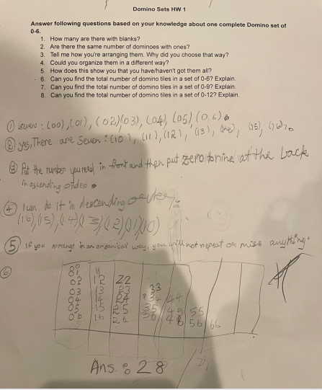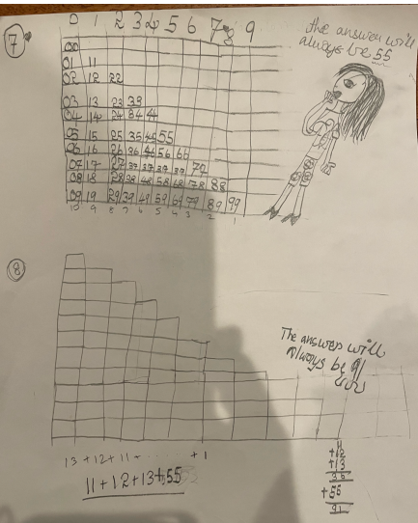
Below is Aarav’s work:
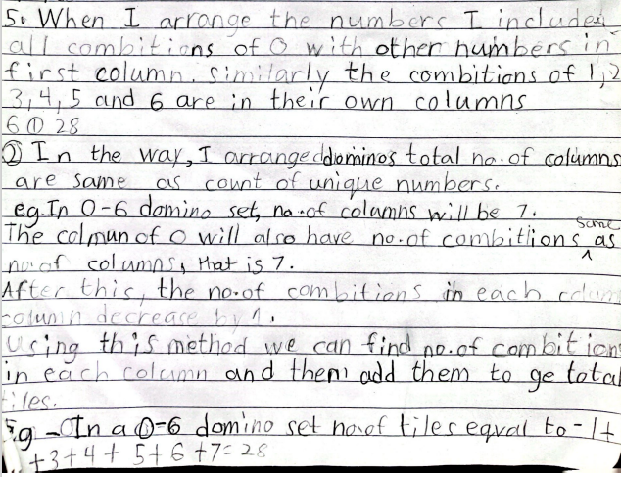
Aniket and Anirudh’s work:

Q. Tell me how you're arranging them. Why did you choose that way?
Answer: I would do like 00-06 will be on the top and 11-16 will be below and so on.

Q. How does this show you that you have/haven't got them all?
You can check if all the numbers to the numbers with ones as 6 have been covered except the ones that are already written.

Q. Can you find the total number of domino tiles in a set of 0-6? Explain.
Answer: I did calculation in my mind and my answer is 28 because the numbers I got at last were 7, 6, 5, 4, 3, 2 and 1. So I added them and I found 28.

Q. Can you find the total number of domino tiles in a set of 0-9? Explain.
00, 01, 02, 03, 04, 05, 06, 07, 08, 09 = 10
11, 12, 13, 14, 15, 16, 17, 18, 19 = 9
22, 23, 24, 25, 26, 27, 28, 29 = 8
33, 34, 35, 36, 37, 38, 39 = 7
44, 45, 46, 47, 48, 49 = 6
55, 56, 57, 58, 59 = 5
66, 67, 68, 69 = 4
77, 78, 79 = 3
88, 89 = 2
99 = 1
10 + 9 + 8 + 7 + 6 + 5 + 4 + 3 + 2 + 1 = 55

Q. Can you find the total number of domino tiles in a set of 0-12? Explain.
00, 01, 02, 03, 04, 05, 06, 07, 08, 09, 10, 11, 12 = 13
11, 12, 13, 14, 15, 16, 17, 18, 19, 110, 111, 112 = 12
22, 23, 24, 25, 26, 27, 28, 29,210, 211, 212 = 11
33, 34, 35, 36, 37, 38, 39,310, 311, 312 = 10
44, 45, 46, 47, 48, 49,410, 411, 412 = 9
55, 56, 57, 58, 59, 510, 511, 512 = 8
66, 67, 68, 69, 610, 611, 612 = 7 (next page)
77, 78, 79,710, 711, 712 = 6
88, 89, 810, 811, 812= 5
99, 910, 911, 912 = 4
1011, 1012, 1013 = 3
1111,1112 = 2
1113 = 1
Total count=13+12 + 11 + 10 + 9 + 8 + 7 + 6 + 5 + 4 + 3 + 2 + 1 = 91

NOTE: Amy’s Dominoes was conducted as follow-up activity and I was really surprised to see their thinking, different approaches they used.

