My solution for Strange Bank Account 2
In this bank, you can add £2 at a time and take out £3 at a time. The question was ‘Are there any other ways in which Alison can increase her bank account by £5?’ There are many ways in which she could do this, but I have come up with an algebraic equation to find any number of deposits and any number of withdrawals that will eventually increase the bank account by £5. Here it is:
(3n+1) x +£2 + (2n-1) x -£3= £5
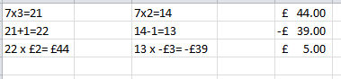
This means that 3n+1 lots of +£2 and 2n-1 lots of -£3 will increase the bank account by £5. For example, if n=7, then 3n+1 will be 22, and 2n-1 will be 13. If you add 22 lots of £2 then take away 13 lots of £3, you will have increased the bank account by £5. This is how I worked that out:

I got the equation by looking at all the ways that you could add 2 and minus 3, like this:
4 x +£2 + 1 x -£3= £5
7 x +£2 + 3 x -£3= £5
10 x +£2 + 5 x -£3= £5
I then worked out the n^{th} term in each sequence and that’s how I got 3n+1 and 2n-1. The equation works with every number, meaning there are as many ways as there are numbers that Alison could use to increase her bank account by £5.

