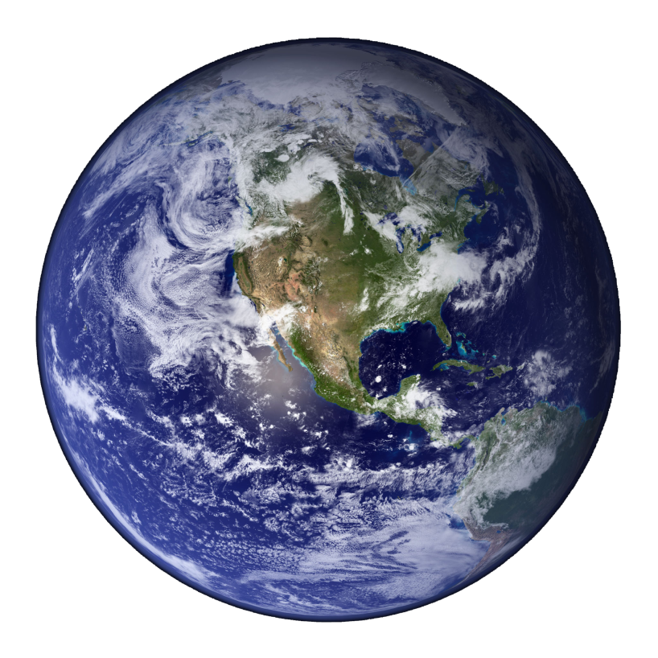
Felix’s Parachute Jump
6371 km
39km

*Diagram not drawn to scale*
Assumptions made/Research:
- The Earth is a perfect sphere
- The Earth’s radius is 6371km
- Felix Baumgartner weight: 70kg
- Acceleration due to gravity: 9.8ms⁻²
- 0-34 seconds, speed goes from 0km/h to 1115 km/h (33,446m)
- Maximum free-fall speed: 1357.6 km/h (achieved 50 seconds into free-fall) (27,833m)
- At 64 seconds: 1042km/h (22,960.7m)
- At 180 seconds: 285km/h (7,619.3m)
- 260 seconds: parachute deployed (1,525m)
- Total time taken: 543 seconds
- Speed with parachute: 191.5km/h
As seen in the diagram, all the red lines and green lines are radii of the Earth. Therefore, they are all 6371km.
- As can be seen by the diagram above, two right angled triangles are formed (due to the tangents – Felix’s range of vision at 39km). The angle formed at the centre, therefore, is given by:
cosѲ=⁶³⁷¹ / ₆₃₇₁₊₃₉
= 0.994ᵒ
(x2)=1.988ᵒ
Now, using this angle, another diameter can be calculated (the circle formed between the two points on the circumference – indicated by the yellow lines).
sin1.988 = ^{r} / ₆₃₇₁
r = 220.99km
Imagining this portion of the earth to be a hemisphere of a much smaller sphere, it’s surface area can be calculated using the ‘surface area of a sphere’ formula (4 π r²):
4 x π x 220.99 = 2777.07km²
However, since he can only see half of this new sphere, this figure must be divided by 2, giving approximately 1389km².
The total surface area (using the surface area of a sphere formula) of the earth, is 510064471.9km².
Therefore, Felix could only see 0.000272% of the earth.
- It took Felix 543 seconds when he did use the parachute. However, just before deploying the parachute, he was travelling at approx. 285 km/h. Felix travelled for 283 seconds with the parachute, at 191.5 km/h, for 1,525m. Had he travelled the remaining 1,525m at a speed of 285km/h, it would’ve taken him just 19 seconds. Therefore, it would’ve taken him a total of 279 seconds (4 minutes and 39 seconds), a whole 4 minutes and 23 seconds less.
- 1357.6 km/h

