I looked at this problem and straight away I knew there was going to be an easy way to find a pattern. But first I had to record and this is what I discovered.
Number of Triangles | Number of Matches | What they form
1 | 3 | 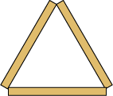
3 | 9
9 | 18 | 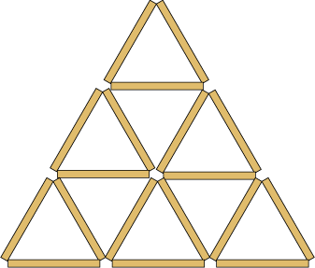
18 | 30
30 | 45

The first thing that I noticed was that the number of matches was the same number as the number of triangles the next time. What I didn’t notice so easily was the pattern that would find me the answer to the next number of matches from the one before.
If you look closely you will notice that from the number of triangles you want to make you can find out how many matches are needed. I look at the order of the numbers…
1, 3, 9, 18, 30, and 45. I looked for the most simplest of patterns, which is the number increasing by the same amount. But the numbers I came up with didn’t match the ones on my graph. This time I looked at the difference of the numbers and realised that the difference between the two numbers was going up by threes.
From this explanation I can now be sure about the next numbers that will come after 45…
63, 84, 108, 135, 165.
Problem by Taylor

