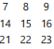 in the four corners 7+9+21+23 = 60

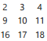 in the four corners 2+4+16+18 = 40

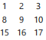 in the four corners 1+3+15+17 = 36

All the results are multiples of four.
The numbers on top-left and top-right corners will always add up to be even because they can only be a pair of even or a pair of odd.
On the bottom it is the same. Two evens always adds up to a multiple of four.

If the totals are divided by four it makes the number in the center of the square. This is because by dividing by four it makes the average. It is the number in the center because:
- Diagonally from the northeast corner to the southwest corner, the distance is 6 because it is one week minus one day. The plus 6 and the minus 6 cancel each other out.
- Diagonally from the northwest corner to the southeast corner, the distance is 8 because it is one week plus one day. The plus 8 and the minus 8 cancel each other out.

adding the numbers in each row, column and diagonal that passes through the centre number results in the same number 45.

adding the numbers in each row, column and diagonal that passes through the centre number results in the same number 30.

adding the numbers in each row, column and diagonal that passes through the centre number results in the same number 27.

The column is equal to the diagonal because in the diagonal northeast to southwest the corner northeast is +1 over the northern number and the southwest corner is -1 under the southern number this then equalizes to make the same result; it is the same for the opposite diagonal.

The column is equal to the horizontal because the northern number is -6 under the eastern number, and the southern number is +6 over the western number which then equalizes. The difference is six because inside the columns of a calendar the numbers grow by 7, which corresponds to the number of days in a week. Inside the rows of a calendar the numbers grow by 1, which corresponds to 1 day at a time. So it is 6 because 7-1=6.

When the total of the diagonals, horizontals or the verticals is divided by three it makes the center number. This is because the sum divided by three is the average. The average is the number in the center because the distance from the center is the same on both sides:
- Horizontally, the distance is 1 because of the days.
- Vertically, the distance is 7 because of the days in a week.
- Diagonally from the northeast corner to the southwest corner, the distance is 6 because it is one week minus one day.
- Diagonally from the northwest corner to the southeast corner, the distance is 8 because it is one week plus one day.

rows= 90 column=90
rows=60 column=60
rows=54 column=54

The sum of the columns and the sum of the rows are equal. The sum of the columns or the sum of the rows divided by 6 is equal to the center number. This is because divided by 6 is finding the average.

There are six numbers which are in the sum of the top and bottom rows. Let X denote the number at the center. The top row is X-8, X-7, X-6 and the bottom row is X+6, X+7, X+8 which then equalizes.

There are six numbers which are in the sum of the left and right columns. Let X denote the number at the center. The left is X-8, X-1, X+6 and the right column is X-6, X+1, X+8 which then equalizes.

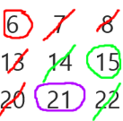 total=42
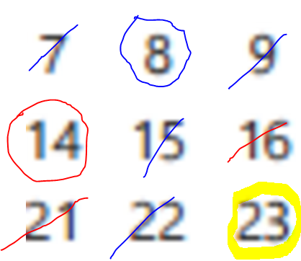total=45
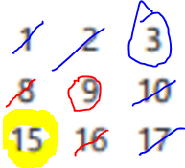total=27
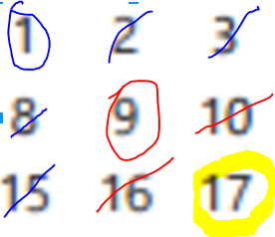total=27
Total divided by three will make number in the center. This is because dividing by three is finding the average. X is the number in the center. The reason why the average is in the center is because the three number gaps from X cancel out.
One of the circled numbers has to be on each of the three columns
If it is on the left one then it will be offset by -1 due to the days.
If it is on the middle one then it will be on the same column as X meaning that it is not offset by the days.
If it is on the right one then it will be offset by +1.

One of the circled numbers has to be on each of the three rows
If it is on the top one then it will be offset by -7 due to the 7 days in a week.
If it is on the middle one then it will be on the same row as the X meaning that it is not offset by the week.
If it is on the top one then it will be offset by +7 due to the 7 days in a week.

The differences can be combined but cannot be overlapped meaning that it will cancel out.

