Kite in a Square
Link: https://nrich.maths.org/kiteinasquare
I enjoyed solving this problem using all the approaches and I believe that they were all smart and interesting methods to work out the shaded area. But I liked the similar figure approach because it was the simplest out of the three and the quote “Mathematics is for lazy people” clearly explains the reason I liked this certain approach.

Pythagoras Approach
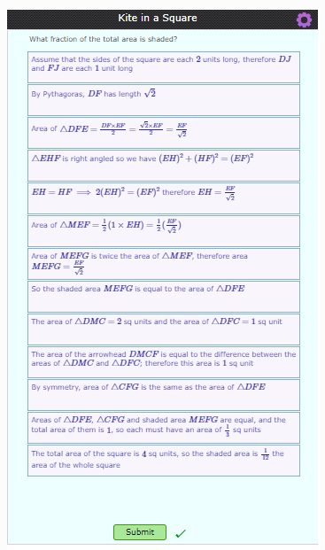

Coordinates Approach
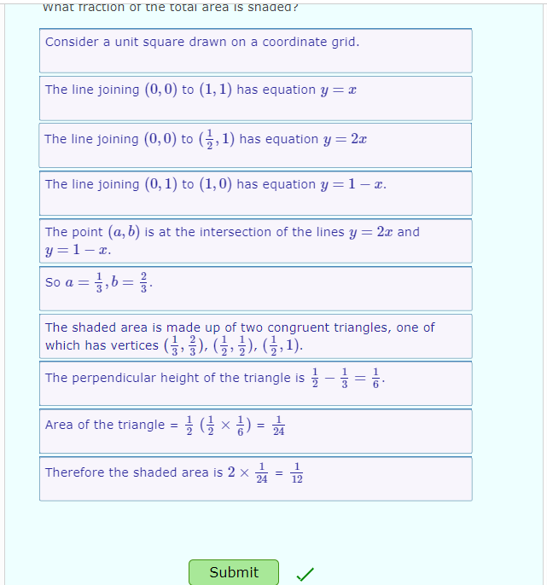

Similar Figures Approach
