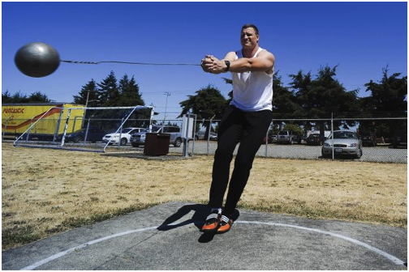
The man is swing the hammers throw at a 90 degree angle. He does at least 5 to 6 360 degree turns before he releases the hammer throw.

