The discus throw.
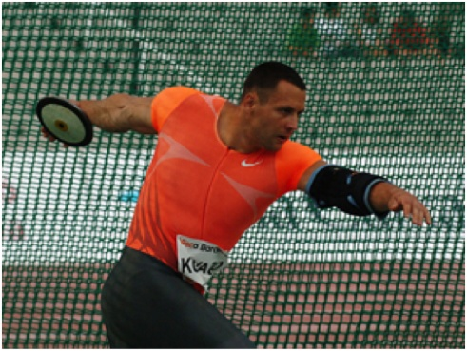
The man brings the discus right behind him and then he swing it round at a 90 degree angle then 45 degrees up, all in one motion. He must also turn his hips 45 degrees to give lots more power to his arms, this will help him achieve a throw with lots of power.

