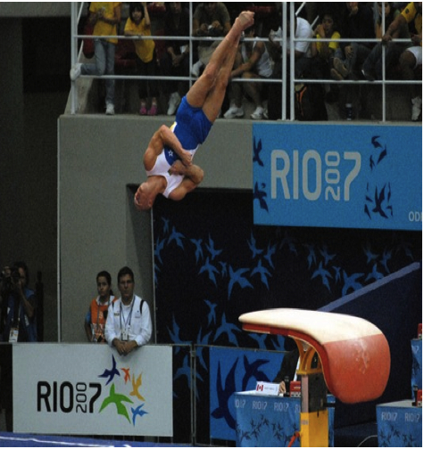
The gymnast is doing about 3 360 degree turns before he makes contact with the ground. In the photo he is at a 20 degrees angle. In the end he would of done a 180 degrees turn.

