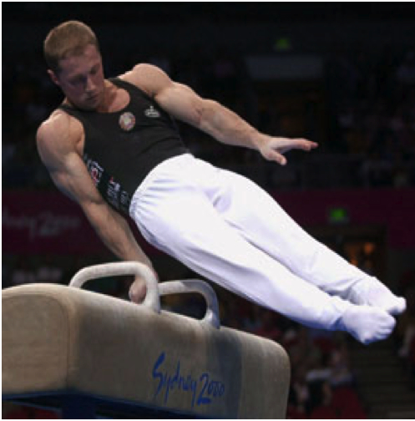

He has to keep his body at a certain angle.
My estimated angle would be of his body 45 degrees.
He is at an angle where he is not vertical and he is not horizontal to the gymnastic equipment.

