The Hammer throw
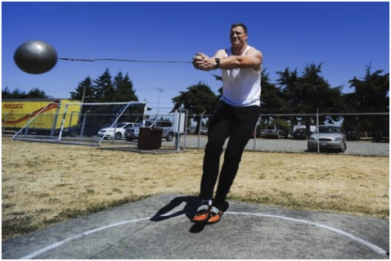
The man makes 5-7 360 degree spins and the ball will rise to 45 degrees then the man will let go. He has to be light footed because the ball will spin you and you must spin with it.

