The Hammer Throw
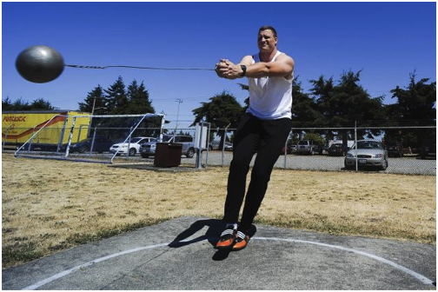

[Type a quote from the document or the summary of an interesting point. You can position the text box anywhere in the document. Use the Drawing Tools tab to change the formatting of the pull quote text box.]

During the hammer throw, the athlete turns a full 360 degrees to get up power. They will do this a couple of times before releasing the hammer to make it go as far as possible.

