Part 1
We cannot simply use the y intercept to determine a singular point within the graphs, as all of the equations (1 – 6) end in +12 or-12, making numerous duplicates within the graphs (A – F).
Therefore, I needed to find the values of the two stationary points that appear in every graph. To achieve this, I used single differentiation for each of the equations.
For example, when considering ${y= x}^{3}+2x^{2}-5x+12$ (equation 1)
$${y= x}^{3}+2x^{2}-5x+12$$
$$\frac{dy}{dx}=3x^{2}+4x-5$$
As we are required to find the stationary point of this equation, we know that the gradient of this particular point must equal to 0 (as tangents to stationary point are always horizontal), we can deduce that in equation 1,
$$3x^{2}+4x-5=0$$
We can next use the quadratic formula to solve this equation,
$$x=\frac{-b±\sqrt{b^{2}-4ac}}{2a}$$
$$x=\frac{-4±\sqrt{4^{2}-4*3* -5}}{2* 3}$$
To 2 decimal places, the result of this calculation results in,
$$x=0.78 and-2.12$$
However, it is clear that these two “x” values for the graph is not sufficient, as we are not given the x axis scale within the graphs A – F, and so, we must use the full co-ordinate of the stationary points to accurately determine the relative equations of the graphs, so, I substituted the calculated “x” values into the original equation (1), for both values of “x” to acquire both values of “y,”
$${y= x}^{3}+2x^{2}-5x+12$$
$${y= 0.78}^{3}+2{* 0.78}^{2}-5* 0.78+12$$
$$OR$$
$${y=\left(-2.12\right)}^{3}+2{*\left(-2.12\right)}^{2}-5*\left(-2.12\right)+12$$
$$y=9.79 and 22.1 (3s.f)$$
And therefore, we are able to successfully acquire the two values of “y” for the two values of “x.” We can refine this, and write the final solution for the two stationary points in co-ordinate notation,
$$\left(0.78, 9.79\right) and (-2.12, 22.1)$$
And now, as we now understand the methodology behind this solution, we can use this same principle for all equations 1 – 6, and I have the results written in hand here:
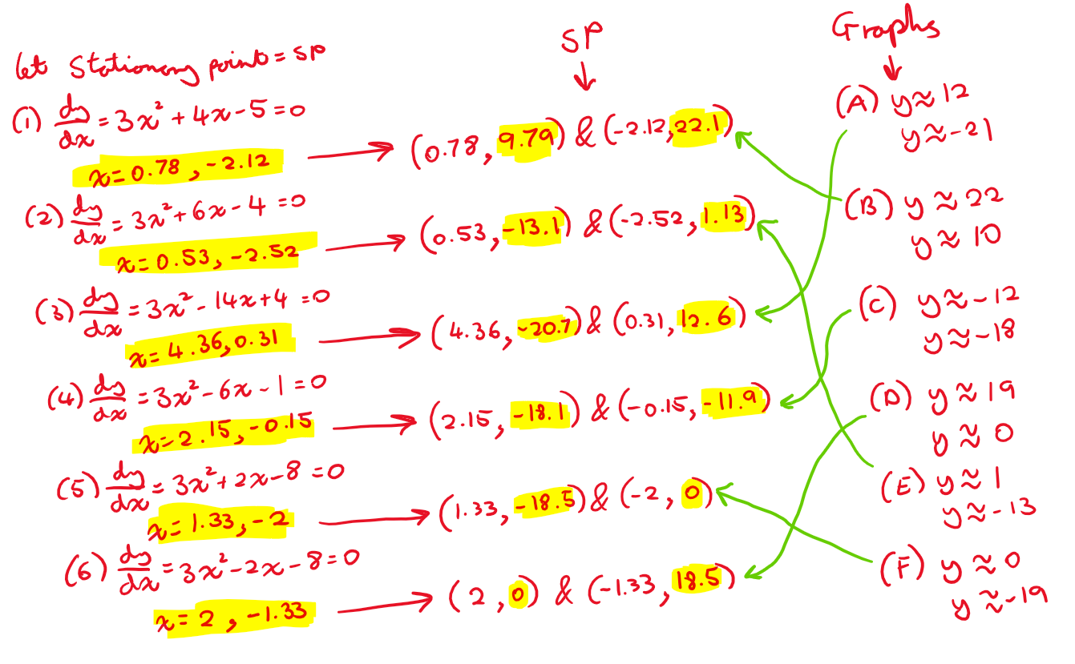
Here, we can see that on the farthest left hand side of the workings out, there are the initial equations 1 – 6 and we have differentiated them, and solved them using the quadratic equation for the two values of “x.” Next we have found the relative y values for the equation, by substituting these into the equation, giving us a neat table of co-ordinated for all the equations, which we can use to match up with their respective graphs.
On the farthest right hand side, I have aligned the graphs from A to F, and I have extrapolated the “y” values from the graphs, by reading off an approximate whole number from the y axis of the stationary points. When unsure, this can also be check by using the x axis readings. Although no scale, we can check if the value is greater than or less than 0 to check our work.
Finally, after matching the graphs to their equations, I am able to conclude that these are my solutions:
- B
- E
- A
- C
- F
- D
Thank you for your time and attention.

