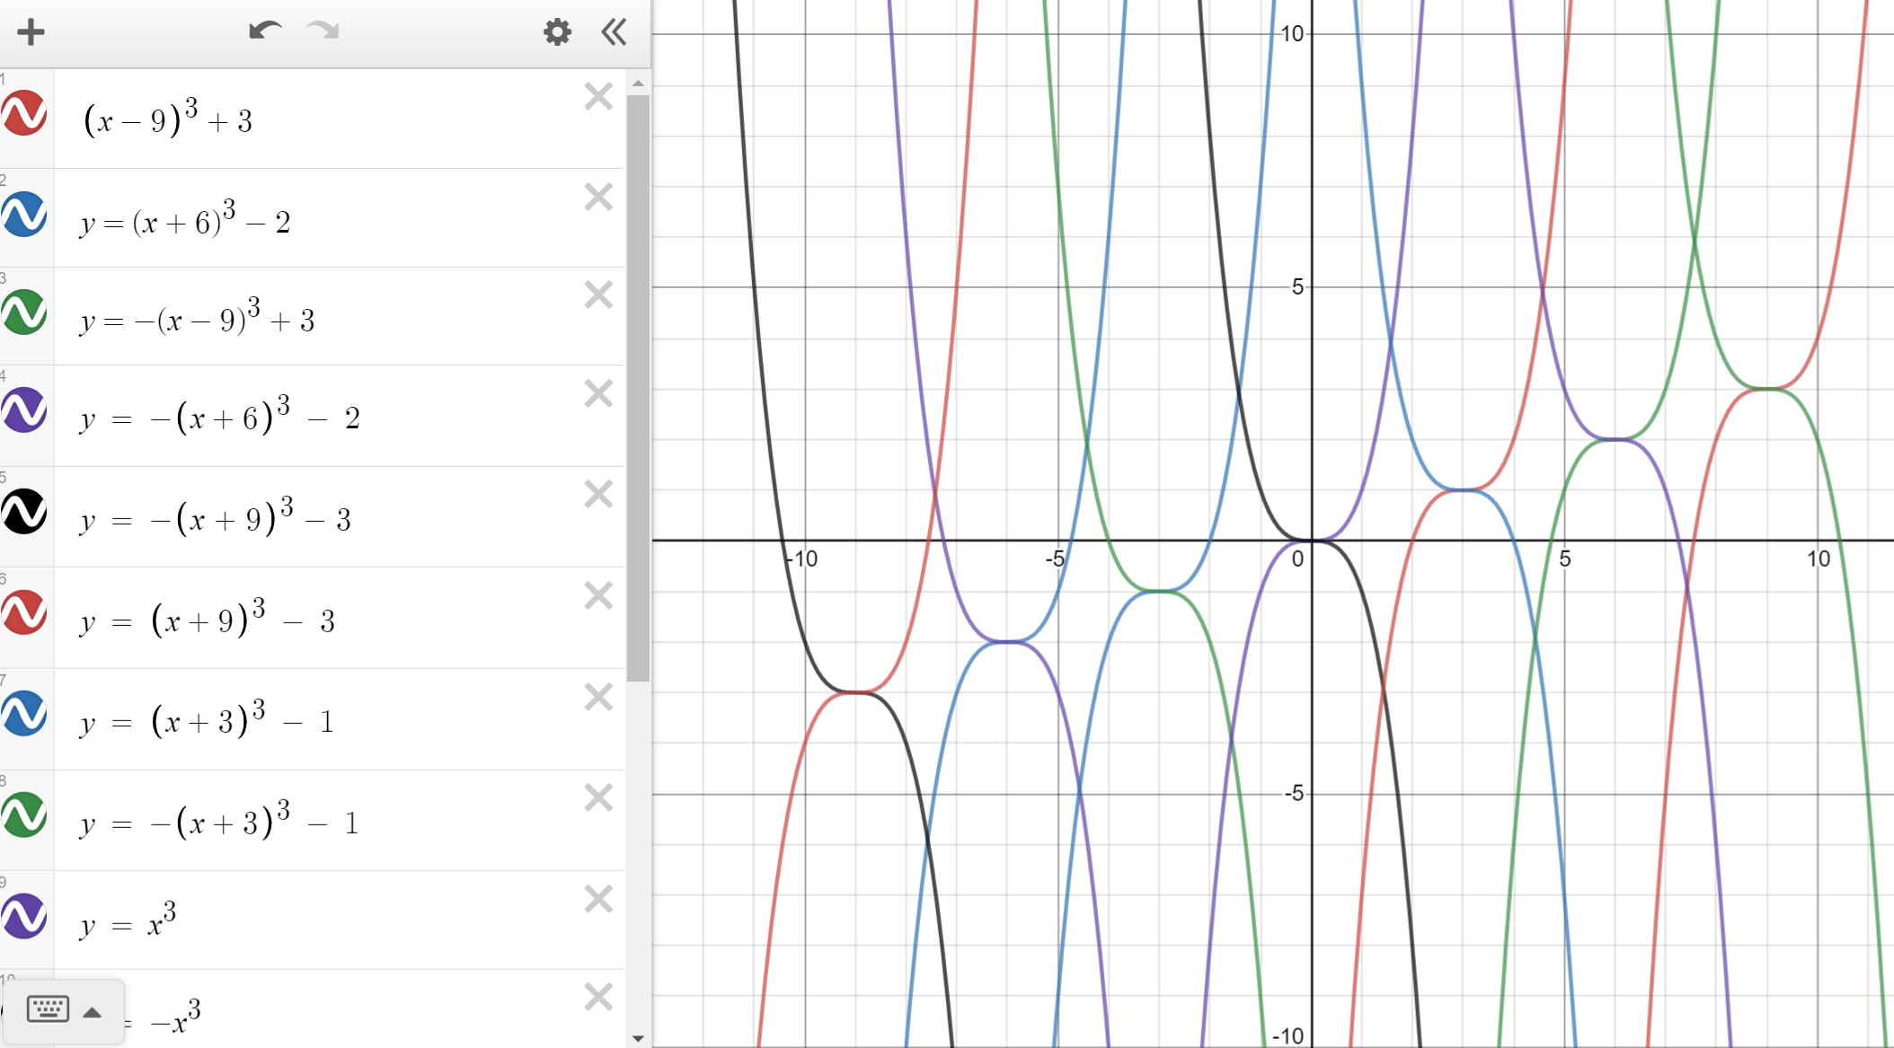
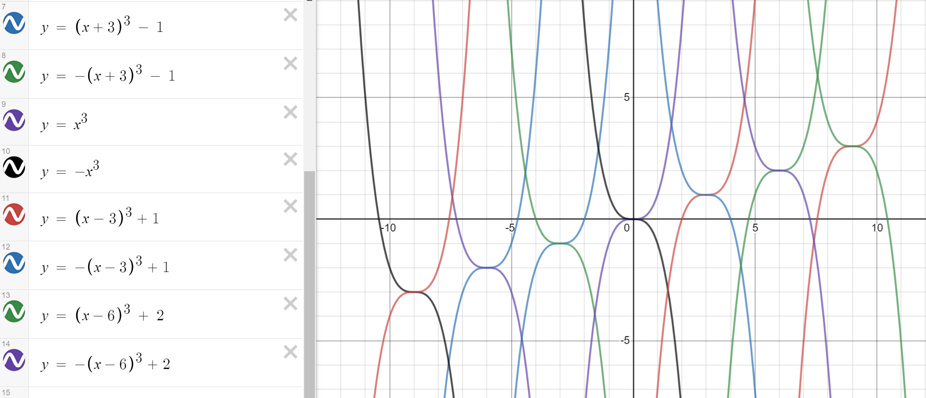

My answers to Question 1.
This would mean that y = (x + a)³ + b.
Where a = -(the distance from x = 0) and b = (the distance from y = 0)

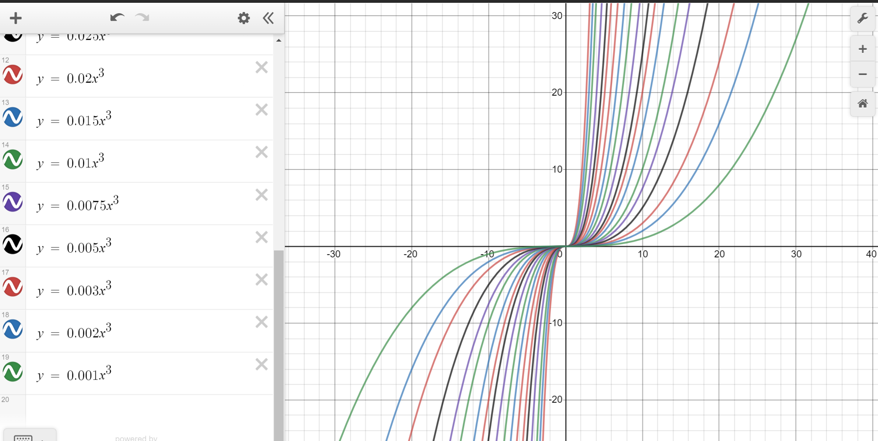
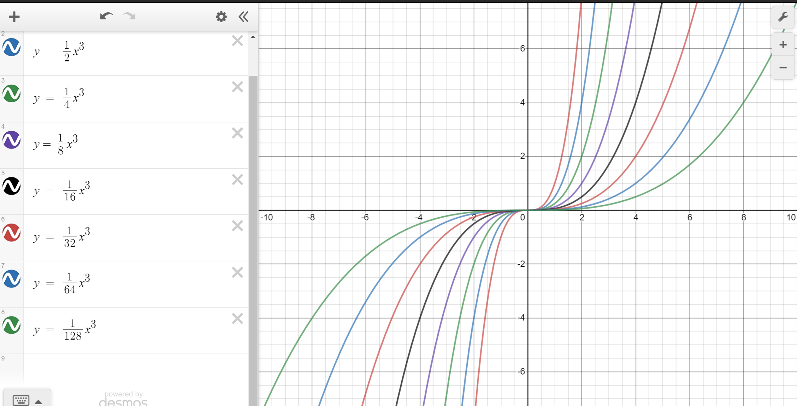
These are the patterns I made using Desmos! The first being a random pattern I did just to make it look nice. The second is 1/ 2^{x}. The second graph shows how quickly the gradient gets less steep.

