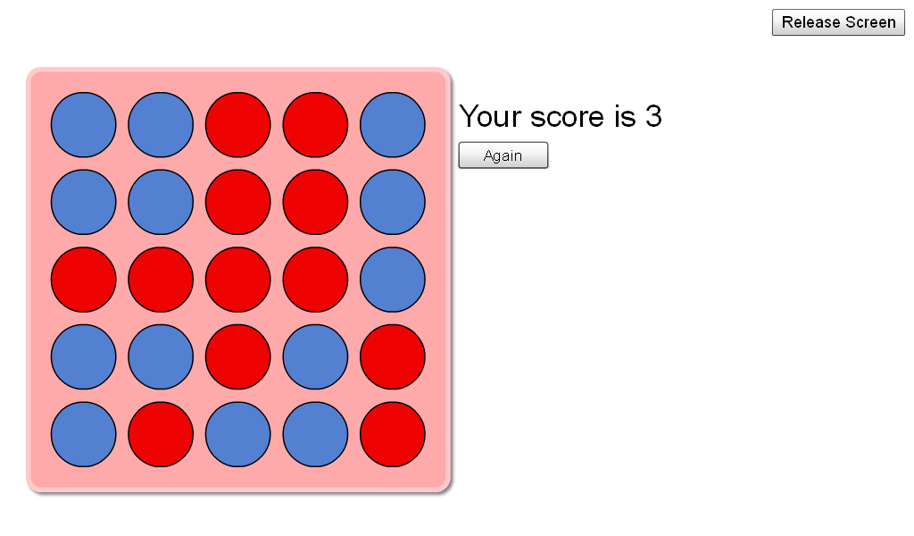
(^^^ This one will not work, as it is either part of the solution or a technical glitch)Depending on how many plugs you have in a line, You get that score. Four in a line will equal 4. Three is the lowest amount you can have in a line to score points. E.G : ..... = 5 ... = 3
Or...
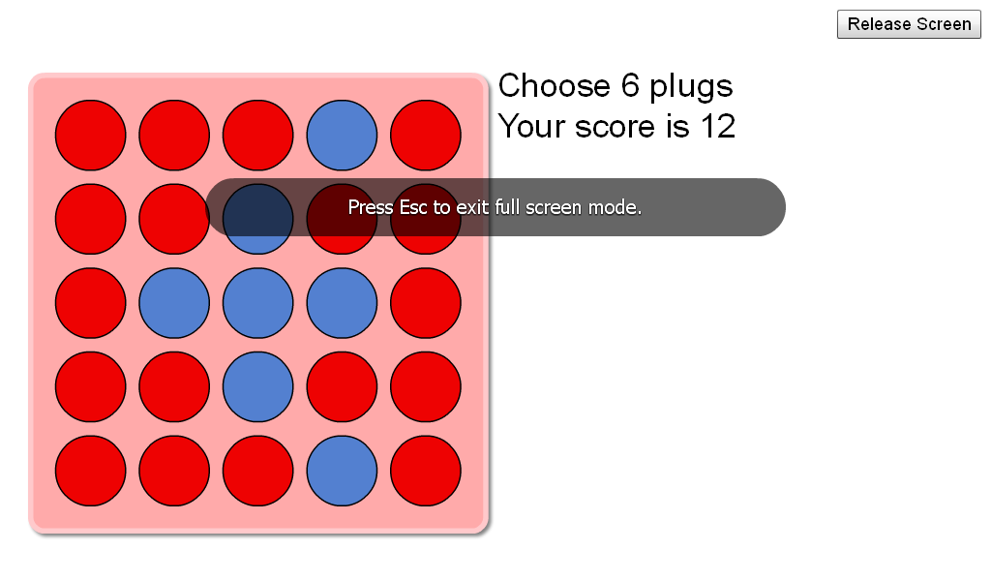This will equal 12, as the lines cross over each other
By Fergus and Roisin.

