Poly Plug instructions
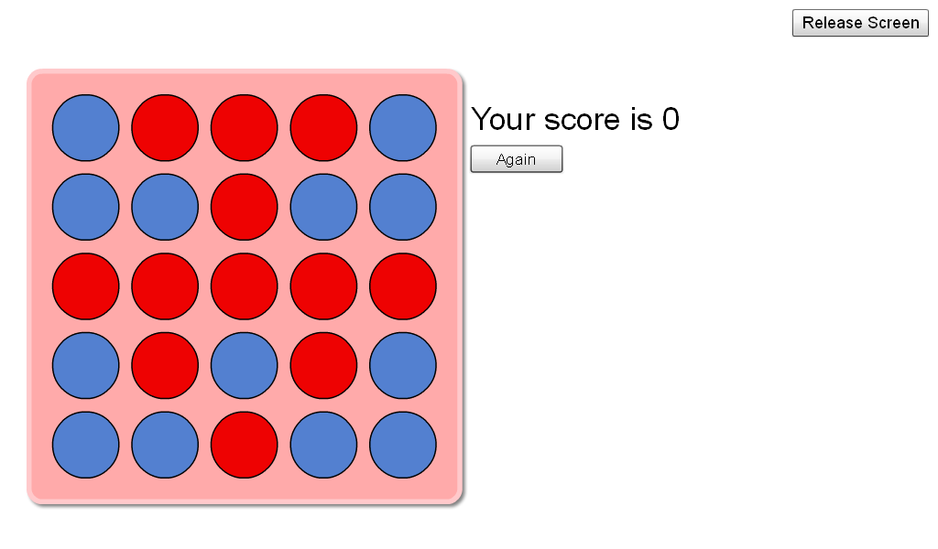

If you want to score 3 points then you would have to do a row of 3 plugs to get the score you can put you plugs horizontally or diagonal. But if you want to get a higher score then you have to do a row of 4 or 5 or put them all bunched up together. The more rows you have the more points you get.

