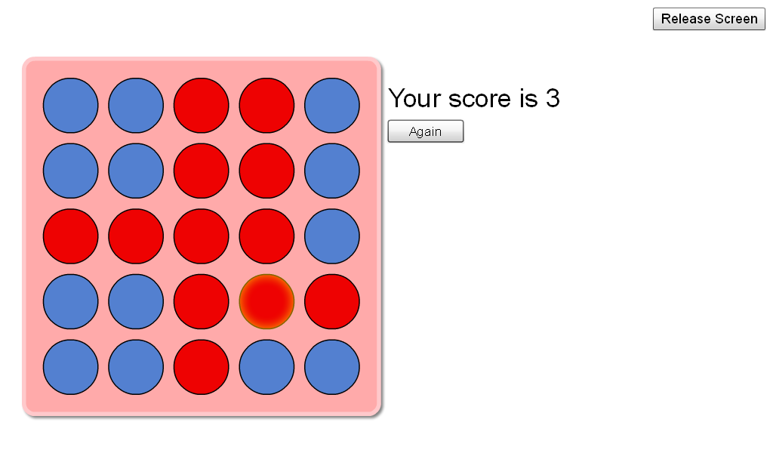
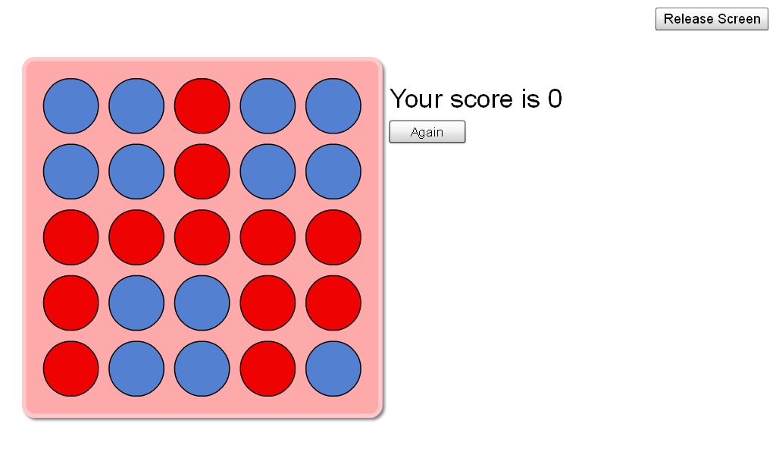
Because there is not a line of plugs you cannot score any points
Now you can score points because of the line of £ on the top right this is what makes your points so for $ points you need a line of four and etc.....

