Myself, Shubhangee, had worked in Ganit Kreeda, Vicharvatika, India with 15 kids, Hiren, Vansh, Eshaan, Rishaan, Samaira, Renah, Udit, Uday, Viha, Gowri, Arya, Vishnu, Krishna, Rivaan, Miraya of 2nd to 4th grades on Fifteen Cards puzzle.
Initially, kids used trial and improvement method to find the first solution. Slowly, when they were challenged to see if there exist another solution and how many, they started thinking systematically.
Samaira, Eshaan and Rishaan shared their strategies how they worked on it.
All of them used similar strategy of writing down all possible combinations to get required sum as 15, 20,23,16,18 and 21, using 1 to 15 numbers.
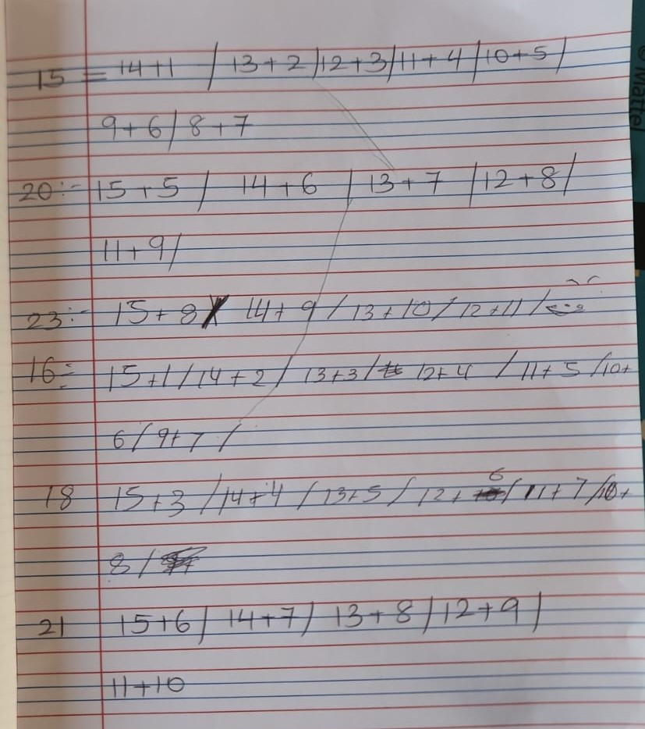
Then we checked the numbers common for each neighbouring pair: Ex: common no.s for 15 and 20 are: 5,6,7,8,9,10,11,12,13,14. We eliminated The numbers that won’t work like…we can’t use 1,2,3,4 for 2nd card.

Finally, we got 2 different combinations:
6 9 11 12 4 14 7
8 7 13 10 6 12 9
Krishna and Viha used little different technique. They started with each number from 1, 2,3… as a first card. Once first card is chosen, we will get one unique answer.

So, Krishna and Viha tested this for all the numbers from 1 to 15 and got only 2 solutions as above.

