Let’s solve each riddle one by one-
First Room
We know that the opposite sides of a dice have a sum = 7 (1 and 6, 2 and 5, 3 and 5)
The top of three dice add up to 8, therefore the sum of the hidden numbers = 7*3 – 8 = 21 – 8 = 13
The key to the first room is 13.
Second Room
Cards | Sum
Card 1 + Card 2 | 13
Card 2 + Card 3 | 9
Card 3 + Card 4 | 11
Card 4 + Card 5 | 16

Since the sum of Card 4 + Card 5 is 16, the only combination for them can be 7 and 9. (8 and 8 is not possible because each card has a unique number)
Assuming Card 4 = 9 and Card 5 = 7,
- Card 3 + Card 4 = 11 => Card 3 = 2
- Card 2 + Card 3 = 9 => Card 2 = 7
- This combination is not possible as Card 2 and Card 5 cannot have the same numbers.
Assuming Card 4 = 7 and Card 5 = 9,
- Card 3 + Card 4 = 11 => Card 3 = 4
- Card 2 + Card 3 = 9 => Card 2 = 5
- Card 1 + Card 2 = 13 => Card 1 = 8
Therefore Card 5 has number 9 i.e. the key to the second room is 9
Third Room
The rectangle is 9cm long and 5 cm wide.
The diameter of the circle will be 5cm. Therefore the center of the circle will be 4 cm apart.
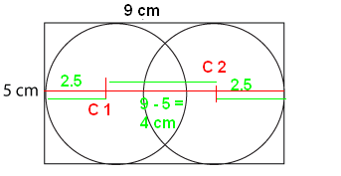
Third key number = 4*4 – 1 = 15
Fourth Room
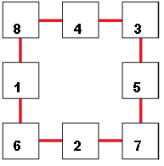
The sum of the corner numbers is 24, therefore the fourth key will be 14.
Fifth Room
The number of tarts is 19. (4*4 + 3 = 19 and 3*6 + 1 = 19)
They key to the fifth room is 19.
The last question
An anagram is a type of word play, the result of rearranging the letters of a word or phrase to produce a new word or phrase, using all the original letters exactly once. Deciphering the code –
13 | M
9 | I
15 | O
14 | N
19 | S
Skippy’s real name is SIMON.

