3 | 18
4 | 17
5 | 16
6 | 15
7 | 14
8 | 13
9 | 12
10 | 11
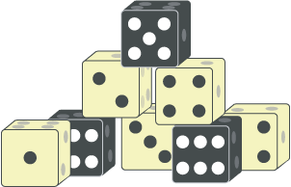
Room 1:

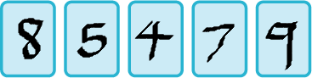
Room 2:

Room 3:
Radius of the circles = 5cm
Diameter = 10cm
Overlapping area = 1cm
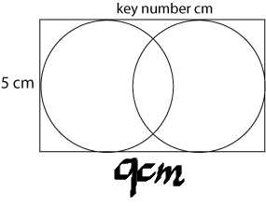
Room 4:
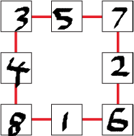
Room 5:
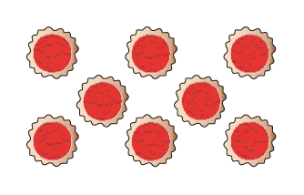

Code:
A=1, B=2, C=3, D=4, E=5, F=6, G=7, H=8, I=9, J=10, K=11, L=12, M=13, N=14, O=15, P=16, Q=17, R=18, S=19, T=20, U=21, V=22, W=23, X=24, Y=25, Z=26

