“Fit for Photocopying”
Nrich

Area sf
What scale factor of enlargement would you need to scale A4 to A3,A2,A1,A0?
A4 = A3 = sf = 2 = 2
A4 = A2 = sf = 4 = 2²
Pattern = 2 to the power of 1,2,3,4,5,6,7,8 etc
A4 = A1 = sf = 8 = 2³
A4 = A0 = sf = 16 = 2⁴

Length sf
A4 = A3 = sf √2 = 1.41...
A4 = A2 = sf √4 = 2
A4 = A1 = sf √8 = 2.82...
A4 = A0 = sf √16 = 4

What is the scale factor for larger to smaller sheets?
A0 = A1 = sf = √1/2 = 0.707...
A0 = A2 = sf = √1/4 = 0.5
A0 = A3 = sf = √1/8 = 0.353...
A0 = A4 = sf = √1/16 = 0.25
A0 = A5 = sf = √1/32 = 0.176...

Area of A0 = 1m²

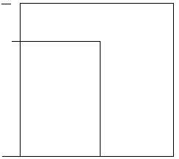
A = 0.8421...
B= 1.1874...
X 100
A = cm = 84.21cm
B = cm = 118.743cm
X .25
A = 21.0525
B = 29.68575
Rounded
A = 21.1cm
B = 29.7cm

1.41... x A or A√2 = b
A0= 1m² area
So
A x A x 1.41... = 1
A² x 1.41... =0.709...
√0.709219858 = a = .8421...
.8421... x 1.41... = 1.18743...
1.187434209 = B
A x B = A0 = 1

B
A
A

