Which is Bigger?

Which is bigger, $n+10$ or $2n+3$?
How did you decide?

Here's how I decided:
"I wonder what happens when $n=4$."
"$4+10=14$ but $2×4+3$ is only $11$."
"So it looks like $n+10$ is bigger."

But then my friend said:
"I wonder what happens when $n=10$."
"$10+10=20$ but $2×10+3$ is $23$."
"So it looks like $2n+3$ is bigger."

Can you explain why we have come to different conclusions?
The two expressions, $n+10$ and $2n+3$, both have a variable in them, meaning the value of the expression depends on the value of the variable. Because the coefficients for the variables are different, the difference between the numerical value of the two expressions can change. Specifically, if the difference between 2n and $n$, or just $n$, is equal to the difference between $10$ and $3$, or $7$, then the two expressions are equal. If $n<7$, $n+10$ is greater:
$$(0)+10>2(0)+3$$
$10>3$
If $n>7$, $2n+3$ is greater:
$$(10)+10<2(10)+3$$
$20<23$
You and your friend used the values $4$ and $10$ as $n$, which produced different conclusions because one was greater than $7$, and the other was less than $7$.

Is there a diagram you could draw that would help?
This graph shows this concept graphically as the green line, representing $2n+3$, is greater than the blue line, representing $n+10$, if and only if $n>7$.
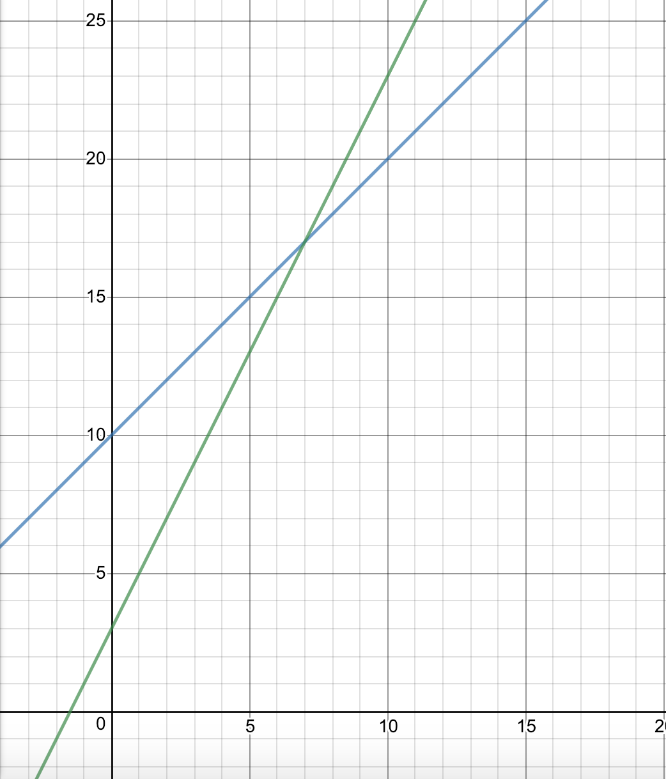
For the following pairs of expressions, can you work out when each expression is bigger?
Let’s set $2n+7<4n+11$. Simplifying this inequality will allow us to find what must be true about the value of $n$ when $4n+11$ is greater than $2n+7$.
$$2n+7<4n+11$$
$7<2n+11$
$-4<2n$
$-2<n$
$4n+11$ is greater than $2n+7$ if $n$ is greater than $-2$, and $2n+7$ is greater than $4n+11$ if $n$ is less than $-2$. We can test this to prove this true:
$$2(0)+7<4(0)+11$$
$7<11$
$-2<0$, so $4n+11>2n+7$.
$$2(-10)+7>4(-10)+11$$
$-13>-29$
$-2>-10$, so $4n+11<2n+7$.

We can apply this method to the other expressions:
$$2(3n+4)<3(2n+4)$$
$6n+8<6n+12$
$8<12$
Since the coefficients of the variables are the same, and $3(2n+4)$ has a greater constant, $3(2n+4)$ is greater regardless of the value of $n$.

$$2(3n+3)<3(2n+2)$$
$6n+6<6n+6$
This is a contradiction because of the reflexive property, which states that identical expressions have identical values. Therefore, the two expressions must be equal, regardless of the value of $n$.

Find two expressions so that one is bigger whenever $n<5$ and the other is bigger whenever $n>5$.
To find two expressions so that one is bigger whenever $n<5$ and the other is bigger whenever $n>5$, we need to perform identical operations to both sides of the equality $n<5$ (or $n>5$).
$n<5$
$2n<n+5$
$$2n+3<n+8$$

$n+8$ is bigger whenever $n<5$, and $2n+3$ is bigger whenever $n>5$.

Find three expressions so that the first is biggest whenever $n<0$, the second is biggest whenever $n$ is between $0$ and $4$, and the third is biggest whenever $n>4$.
Let’s start with the expression $n+10$. If this expression is bigger than the second expression whenever $n<0$, then the first and second expressions must be equal when $n=0$. Let’s set the coefficient of the second expression to $2$, and label the constant $c$. Then:
$$(0)+10=2(0)+c$$
$10=c$
The second expression is $2n+10$. We know that $2n+10$ is greater when $n>0$ and $n+10$ is greater when $n<0$and not vice versa through trial and error:
$$(1)+10<2(1)+10$$
$11<12$
$1>0$, so $n+10<2n+10$.

$$(-1)+10>2(-1)+10$$
$9>8$
$-1<0$, so $n+10>2n+10$.

If $2n+10$ is bigger than the third expression whenever $0<n<4$, then the second and third expressions must be equal when $n=4$. Let’s set the coefficient of the third expression to $3$, and label the constant $c$.
$$2(4)+10=3(4)+c$$
$18=12+c$
$6=c$
The last expression is $3n+6$. We know that $3n+6$ is greater when $n>4$ and $2n+10$ is greater when $n<4$and not vice versa through trial and error:
$$2(5)+10<3(5)+6$$
$20<21$
$5>4$, so $2n+10<3n+6$.

$$2(3)+10>3(3)+6$$
$16>15$
$3<4$, so $2n+10>3n+6$.

Assuming $n+10$ is the first expression, the three expressions are $n+10$, $2n+10$ , and $3n+6$.

Find three expressions so that the first is biggest whenever $n<3$, the second is biggest whenever $n>3$, and the third is never the biggest.
Let’s start with the expression $n+10$. If this expression is bigger than the second expression whenever $n<3$, then the first and second expressions must be equal when $n=3$. Let’s set the coefficient of the second expression to $2$, and label the constant $c$. Then:
$$(3)+10=2(3)+c$$
$13=6+c$
$7=c$
The second expression is $2n+7$. We know that $2n+7$ is greater when $n>3$ and $n+10$ is greater when $n<3$and not vice versa through trial and error:
$$(4)+10<2(4)+7$$
$14<15$
$4>3$, so $n+10<2n+7$

$$(2)+10>2(2)+7$$
$12>11$
$2<3$, so $n+10>2n+7$.

We can represent these two expressions graphically:
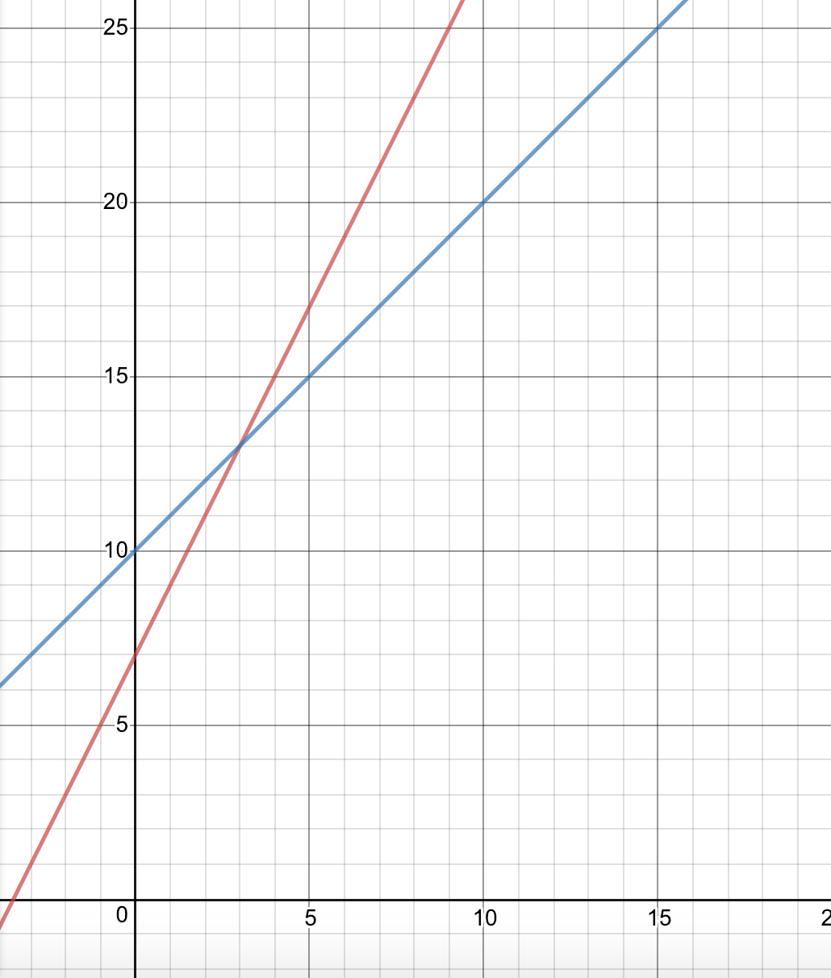
A quadratic graph with a negative coefficient would satisfy the requirement of never being the biggest, as both ends would curve downward. If the quadratic graph is the biggest at one point, we could decrease the constant or move it left/right across the $x$-axis by squaring $n$ add/subtract a constant rather than squaring $n$. In this case, none of this necessary. The graph of $n^{2}$ is in green:

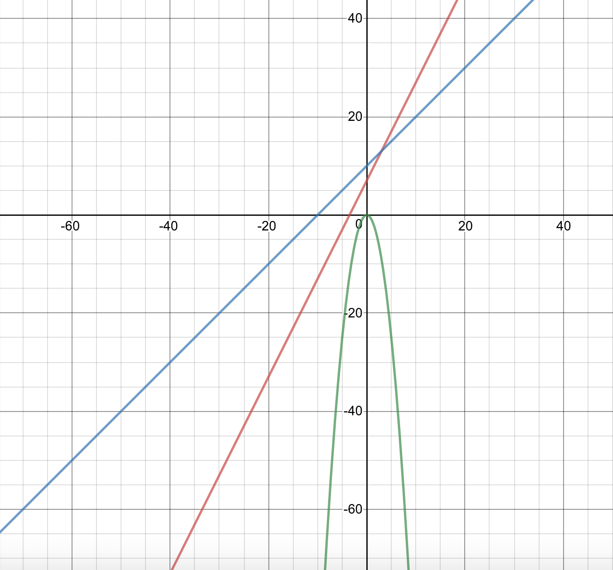
Assuming $n+10$ is the first expression, the three expressions are $n+10$, $2n+7$ , and $n^{2}$.

Find three expressions so that one of them is biggest regardless of the value of $n$.
If three lines in a plane are parallel, they will not intersect - the biggest will not change. Lines that are parallel have the same slope. Therefore, for one expression to be the biggest regardless of the value of $n$, all three expressions must have the same slope. Then, the expression with the highest constant will be biggest.

Since the specific numbers do not matter as long as the coefficients are the same, we can just choose any numbers - let’s say $\frac{1}{2}n+2$, $\frac{1}{2}n+4$, and $\frac{1}{2}n+6$.

The graph below shows that $\frac{1}{2}n+6$ is biggest regardless of the value of $n$:
