You know from how many times the shape is cut that it is a quarter of the length of the original shape so if you add up all the lengths you will get 10 and when you add up all of the widths it equals 4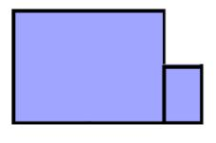
width
length


But if the smallest rectangle is placed on a different length or width and is rotated it can make a different perimeter.
Now the perimeter is 8a +6b.

