To solve this problem, we used our knowledge of graphs and functions in order to meet the demands of each brief.

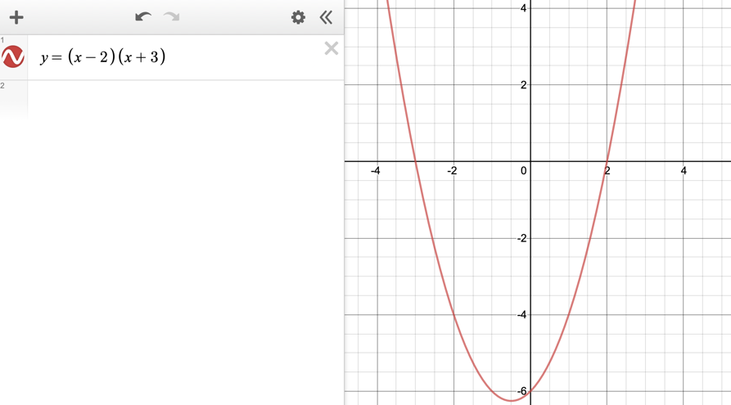
1.

We graphed a parabola with two separate roots, which gave us one point of zero gradient (turning point) and two zeros (roots).
2.
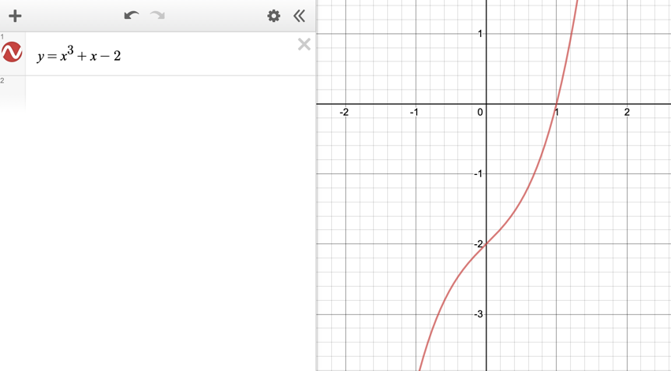

We graphed a cubic function which passes through the x axis once and has a point of inflection- so no points of zero gradient.
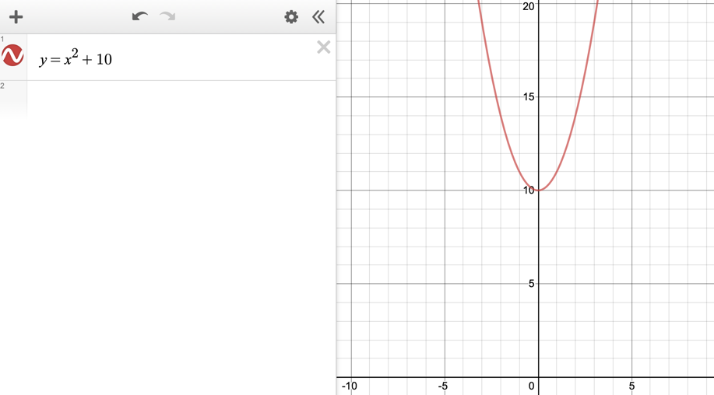
3.

We graphed a parabola with no roots which gave one point of zero gradient.
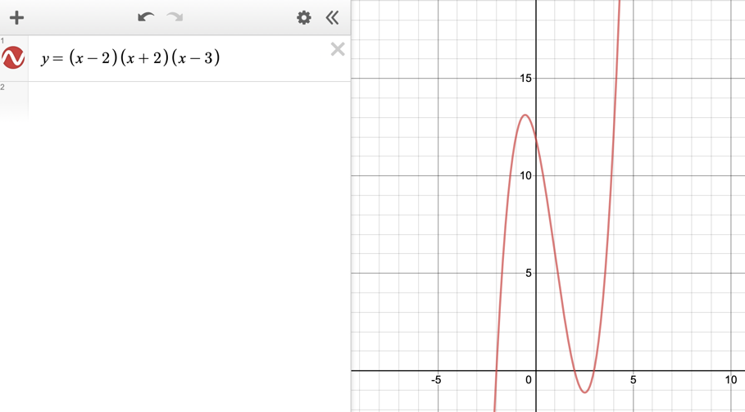
4.

We graphed a cubic with 3 separate roots (3 zeros) and 2 turning points (2 points of zero gradient).

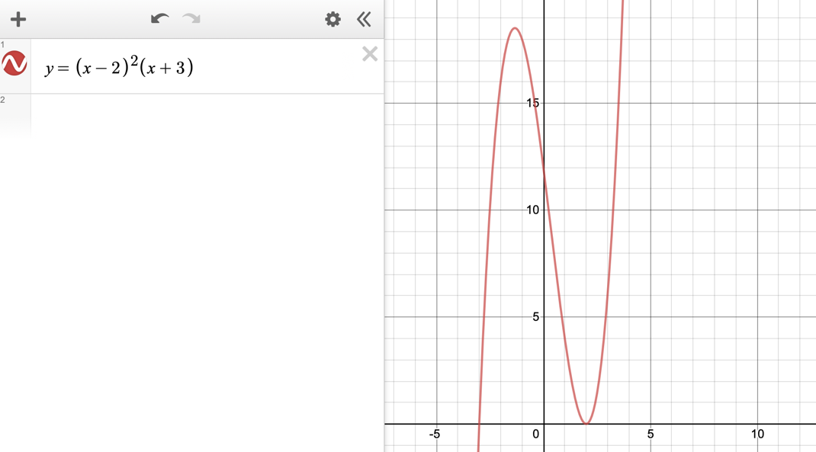
5.

We graphed a cubic with two roots (one repeated root so there are 2 zeros) and two turning points (two points of zero gradient).
6.
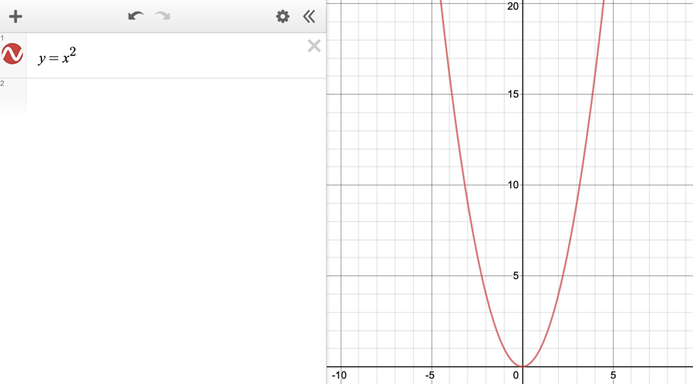We graphed a parabola with one repeated root (one zero and one point of zero gradient).
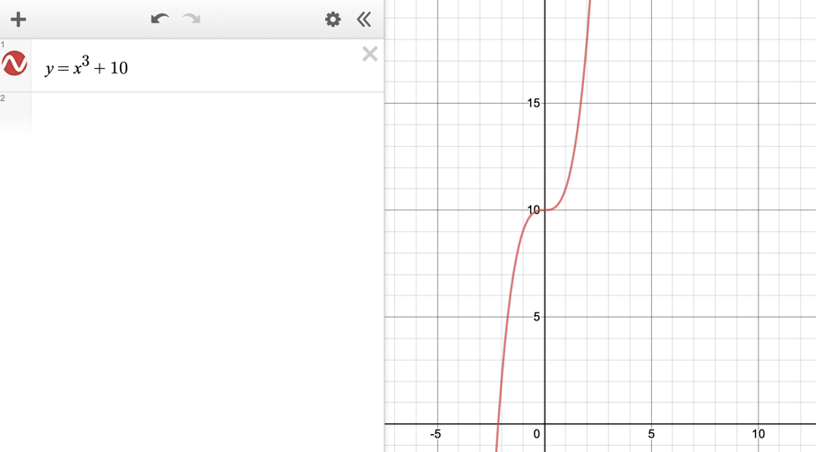
7.

We graphed a cubic with one stationary point (one point of zero gradient) and one intersection with the x axis (one zero).
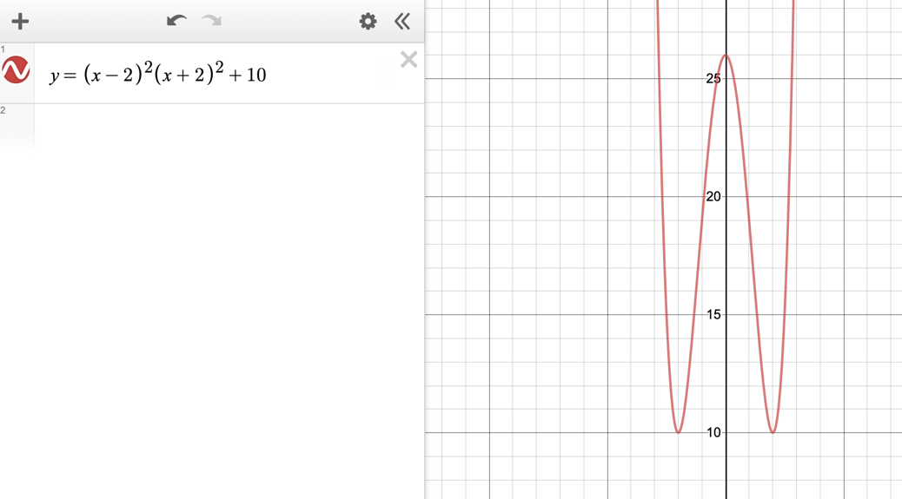
8.

We graphed a quartic function, with two turning points (2 points of zero gradient) and no intersection with the x axis (no zeros).

