Daisy and Akram were making number patterns. Daisy was using beads that looked like flowers and Akram was using cube bricks. First they were counting in twos and their patterns looked like this:

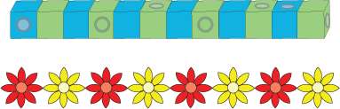

Can you count along them in twos to see who made the longer one?

Akram made the longer chain of cubes.

After this Daisy made another chain and Akram made another row of cubes.

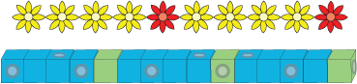
What were they counting in this time? After this they made more.

They were using the pattern 4, 1, 4, 1
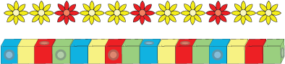

What was Daisy counting in this time? And what do you think Akram was doing with his cubes?

Daisy was using the pattern 2, 1, 2, 1, 2, 1, 2

Akram was using the pattern 1, 2, 3, 4, 1, 2, 3, 4, 1, 2, 3, 4

Can you make some chains and some rows of cubes counting in different numbers? You could use squared paper to help you draw the cubes.

