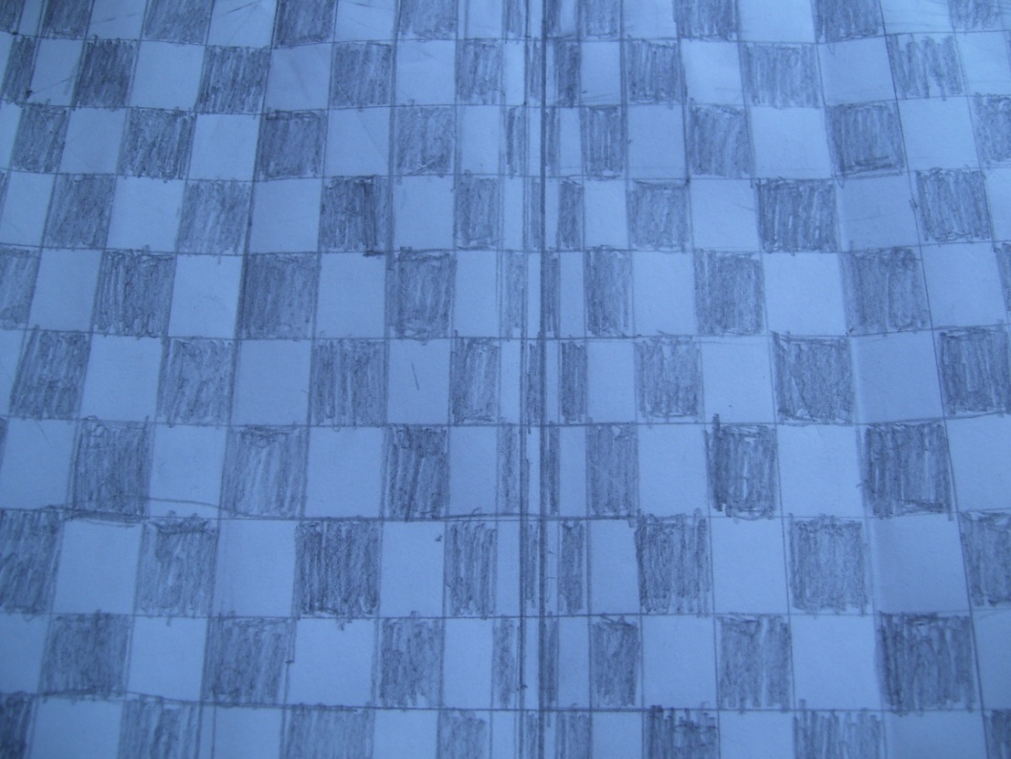
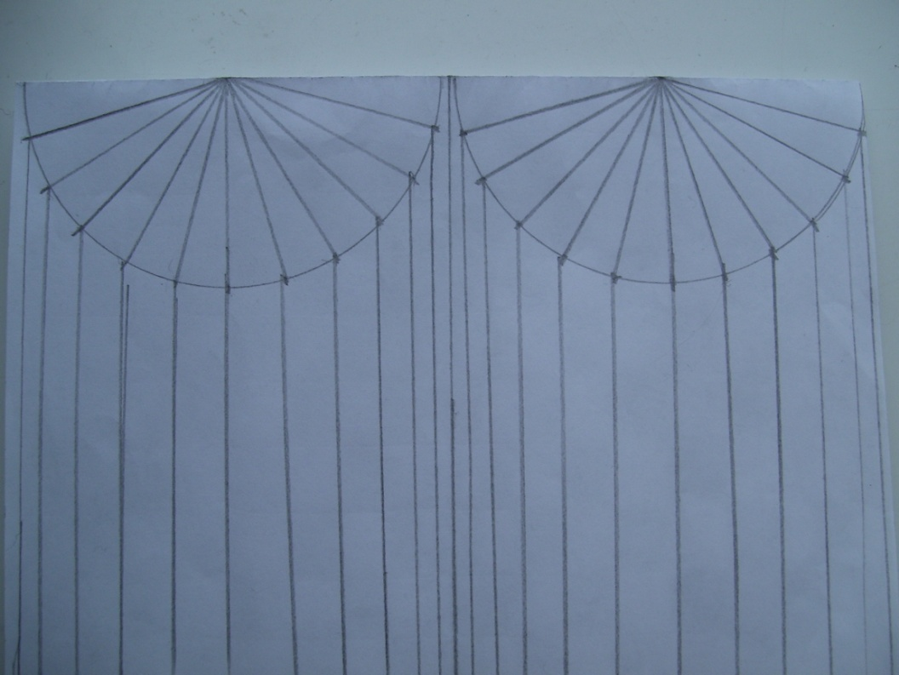
This is how I drew the picture:
First I drew 2 semicircles on the top of the page (to represent the tops of the cylinders).
Next I marked out 15° along the semi-circles and drew lines coming out from them.
Then I rubbed out the semi-circles and extended the lines running vertically along the page.
Finally I drew the horizontal lines (so that the lines in the middle made a square) and coloured it in.
Moving Squares

