The Celtic Knot
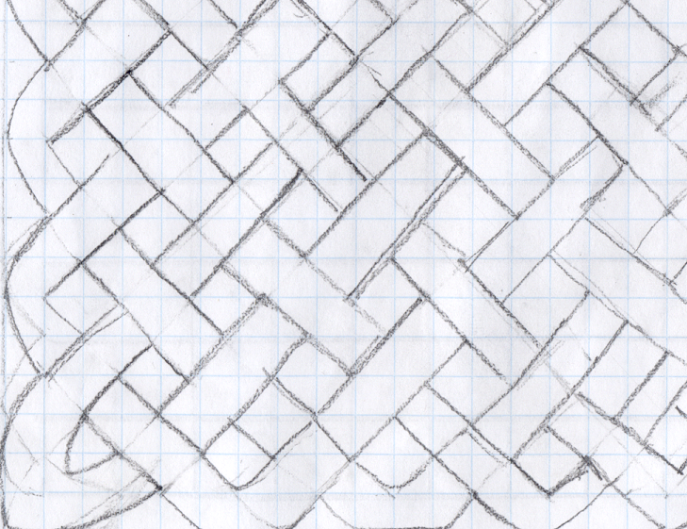
This is just part of my solution. I followed the instructions on your website but carried on to make it bigger. I scanned the picture I produced on to the computer. I discovered you have to keep doing boxes of three in directions when they cross the one that has two or less carries on the other will start at one box at the other side of where they cross. The hardest part of drawing the Celtic knot was the edge which proved difficult to get the correct angle on.
Naomi Atkins
Year 6
King’s Sutton Primary

