Celtic Knots
The Celtic Knot is a repeated pattern. To draw it you use 4 different symbols
Which are: 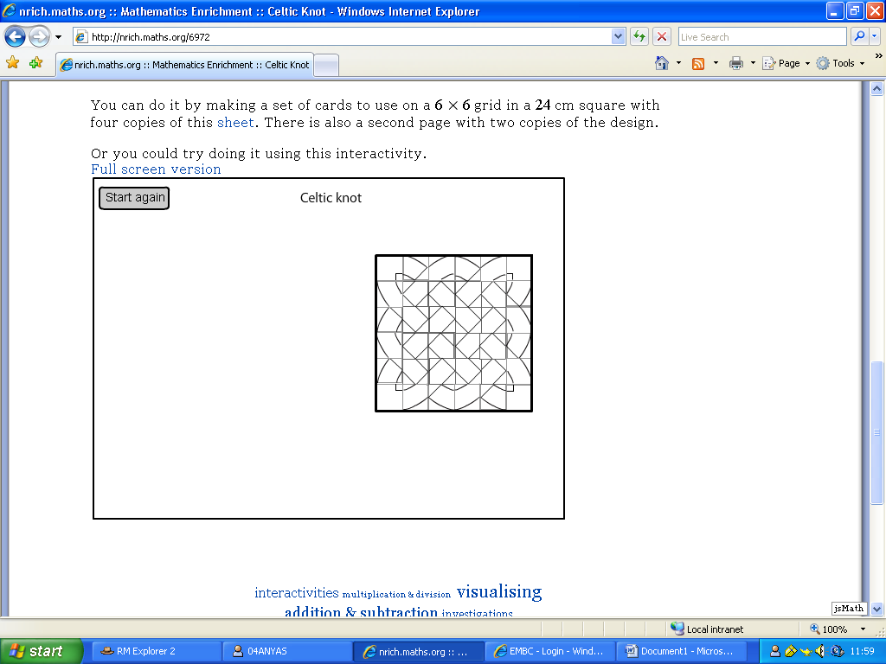
We explored drawing different sizes of celtic knots. First we did a 6x6, using the screen,
Then we did a 10x10 using squared paper.
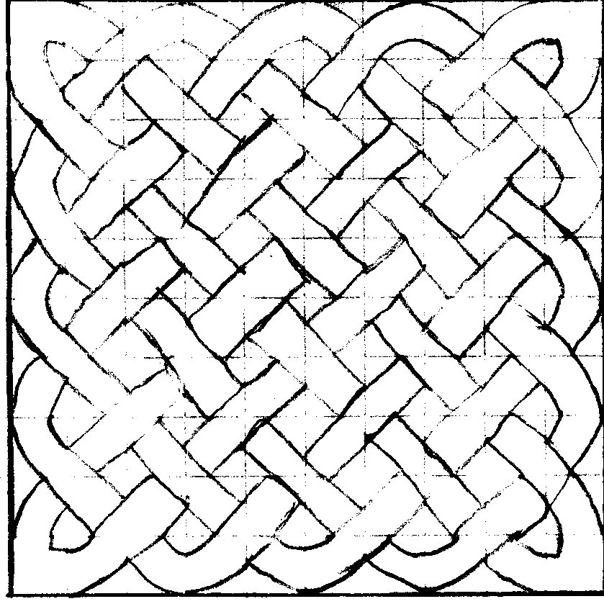
then we started a 32x32 but we didn’t finish it because we didnit feel we needed to. Here is part of the design.
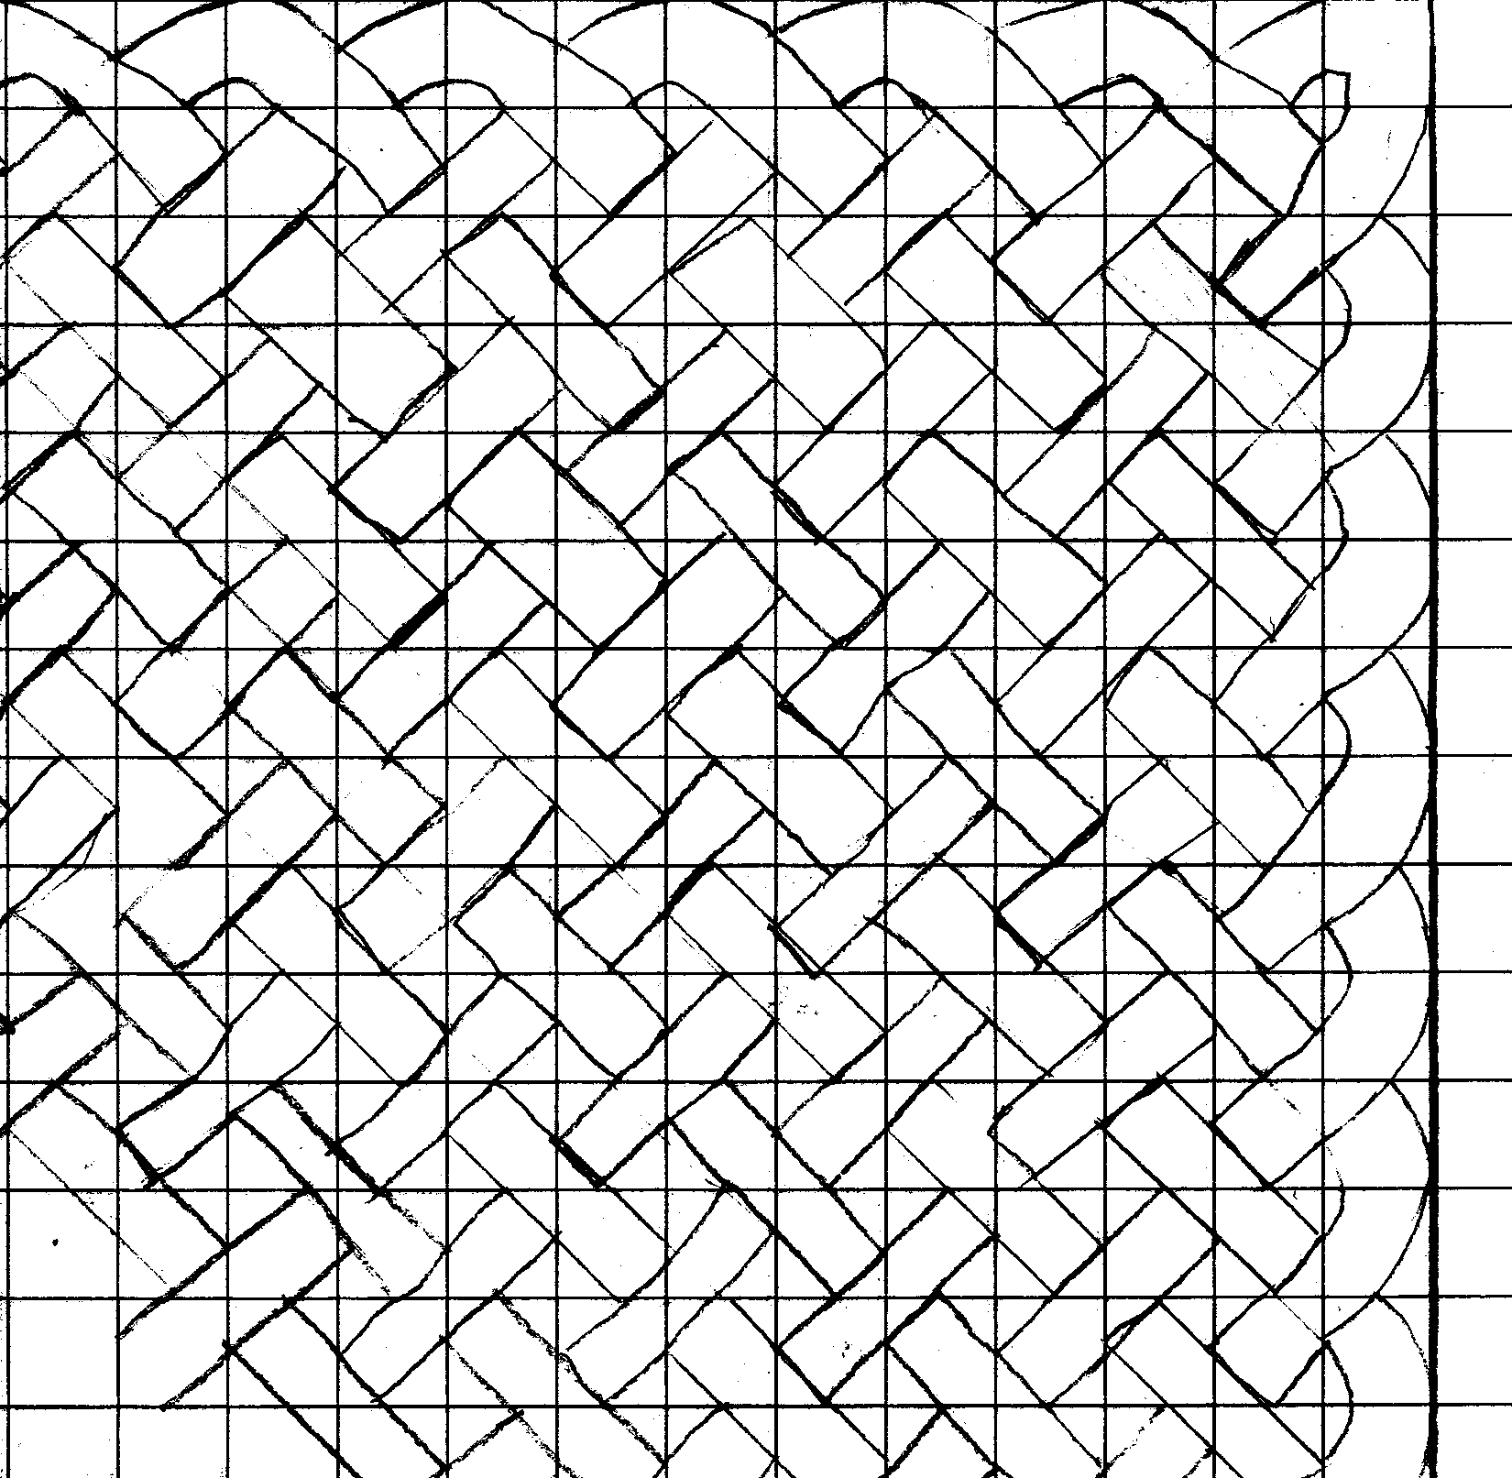
We discovered that you can do rectangular ones so we did a 4x6 then a 40x28 . We also discovered that they have to be an even number by an even number otherwise it will not work because the squares have to be in pairs.
Anya Sims (aged 10) and Gaby Connelly (aged 10) Year 5
King’s Sutton Primary School

