Times Tables Shifts solution for Nrich

Myself Shubhangee (Facilitator) had worked collaboratively on ‘Times Tables Shifts’ with a group of 13 students of 3rd to 6th grade, in online mode, in ‘Ganit Kreeda’, Vicharvatika, India. The names of the students are:
Ahana, Sehar, Saanvi, Dhanvin, Aariz, Ananthjith, Vivaan, Sai, Pranathi, Paavani, Utkarsh, Tavish, Dhruv.
All the kids worked collaboratively during the session using interactivity. Here are the answers they found for all the questions.
What is the same between numbers in a times table and numbers in the shifted times table?
A. The difference between two numbers of the shifted time table is the same as the normal table.

2. What can you learn from the difference between any two numbers in a shifted times table?
A. the difference is the same from the normal table.

3. How do you find the shift once you've worked out the table?
A. Add or subtract the original number from the time table.

4.What can you say if the numbers from the shifted table are all odd?
A. We can say that an odd number is subtracted or added from an even number table.

Sharing pics of some of the kid’s solution:
First 3 images show Sehar’s work:
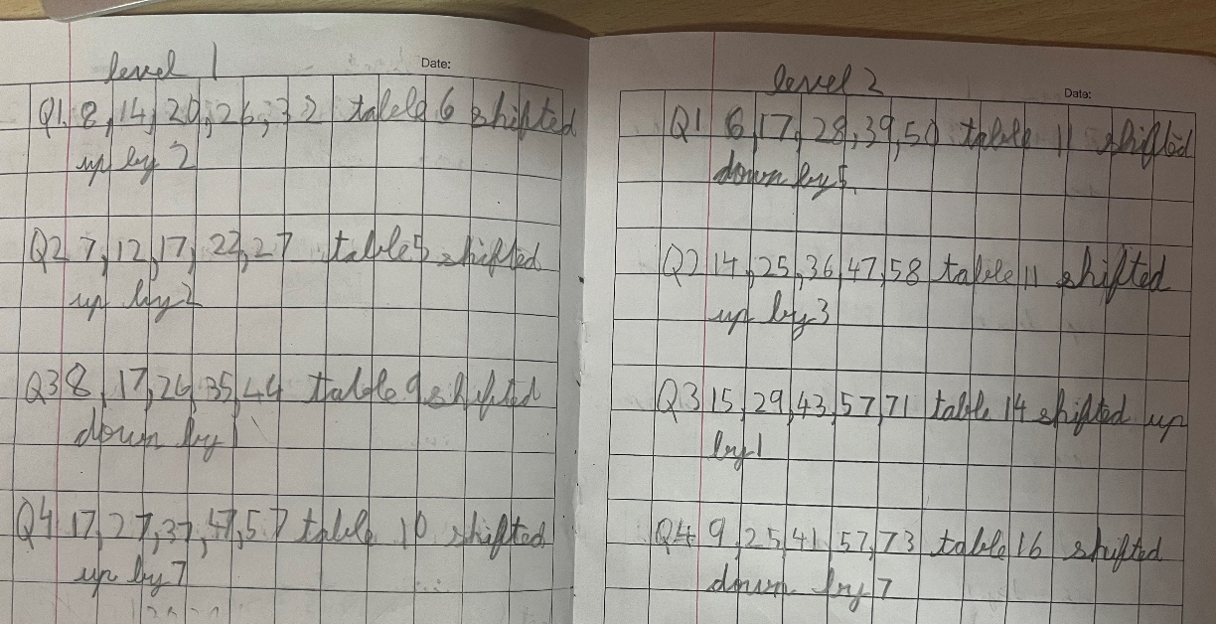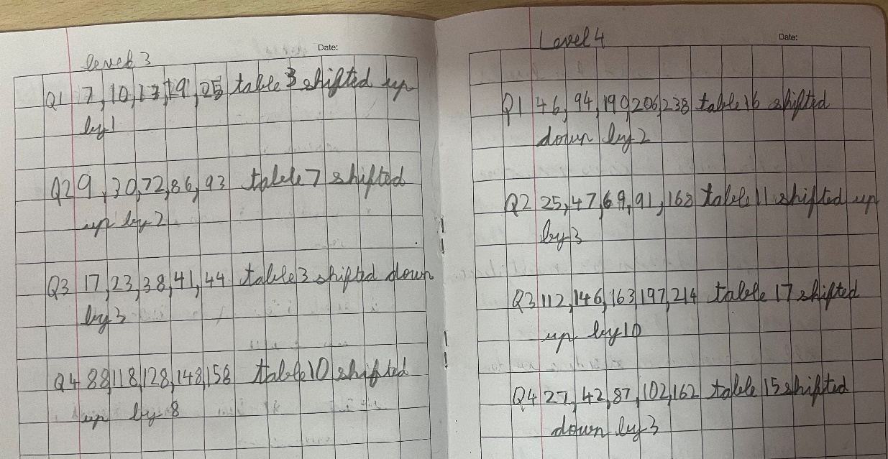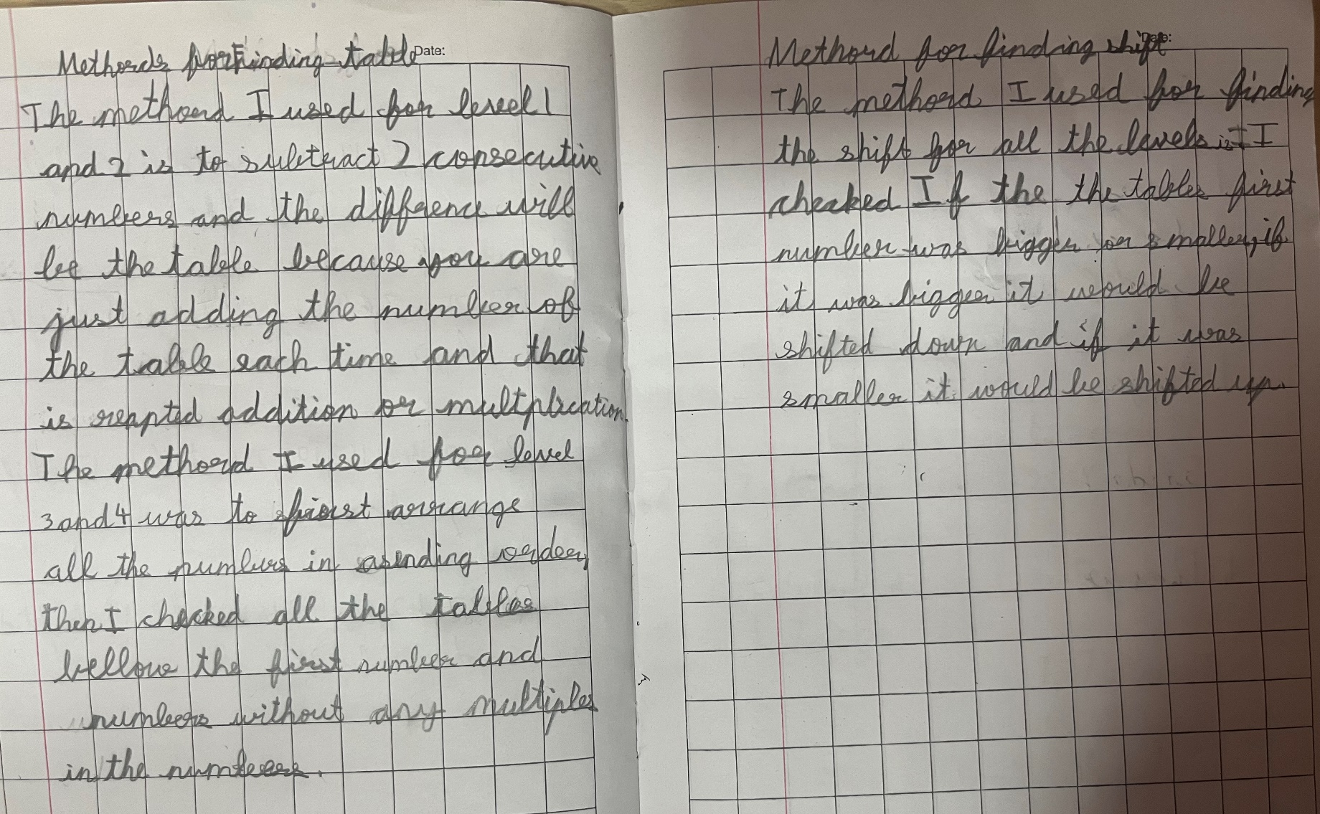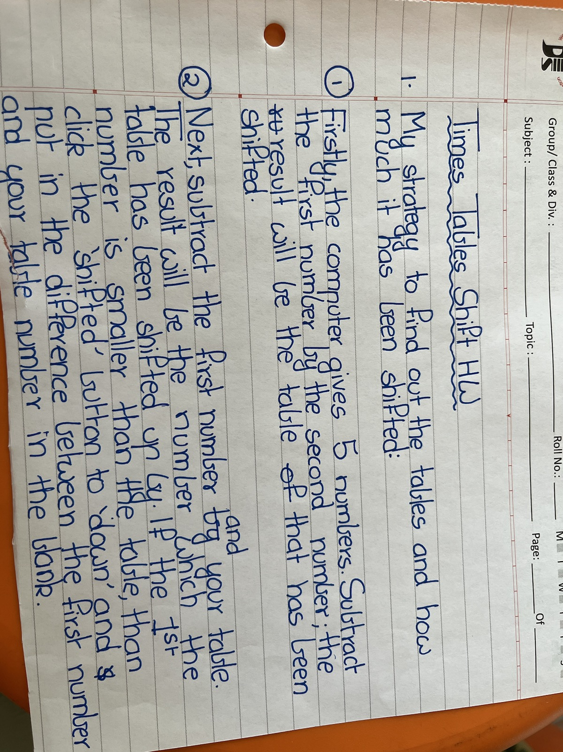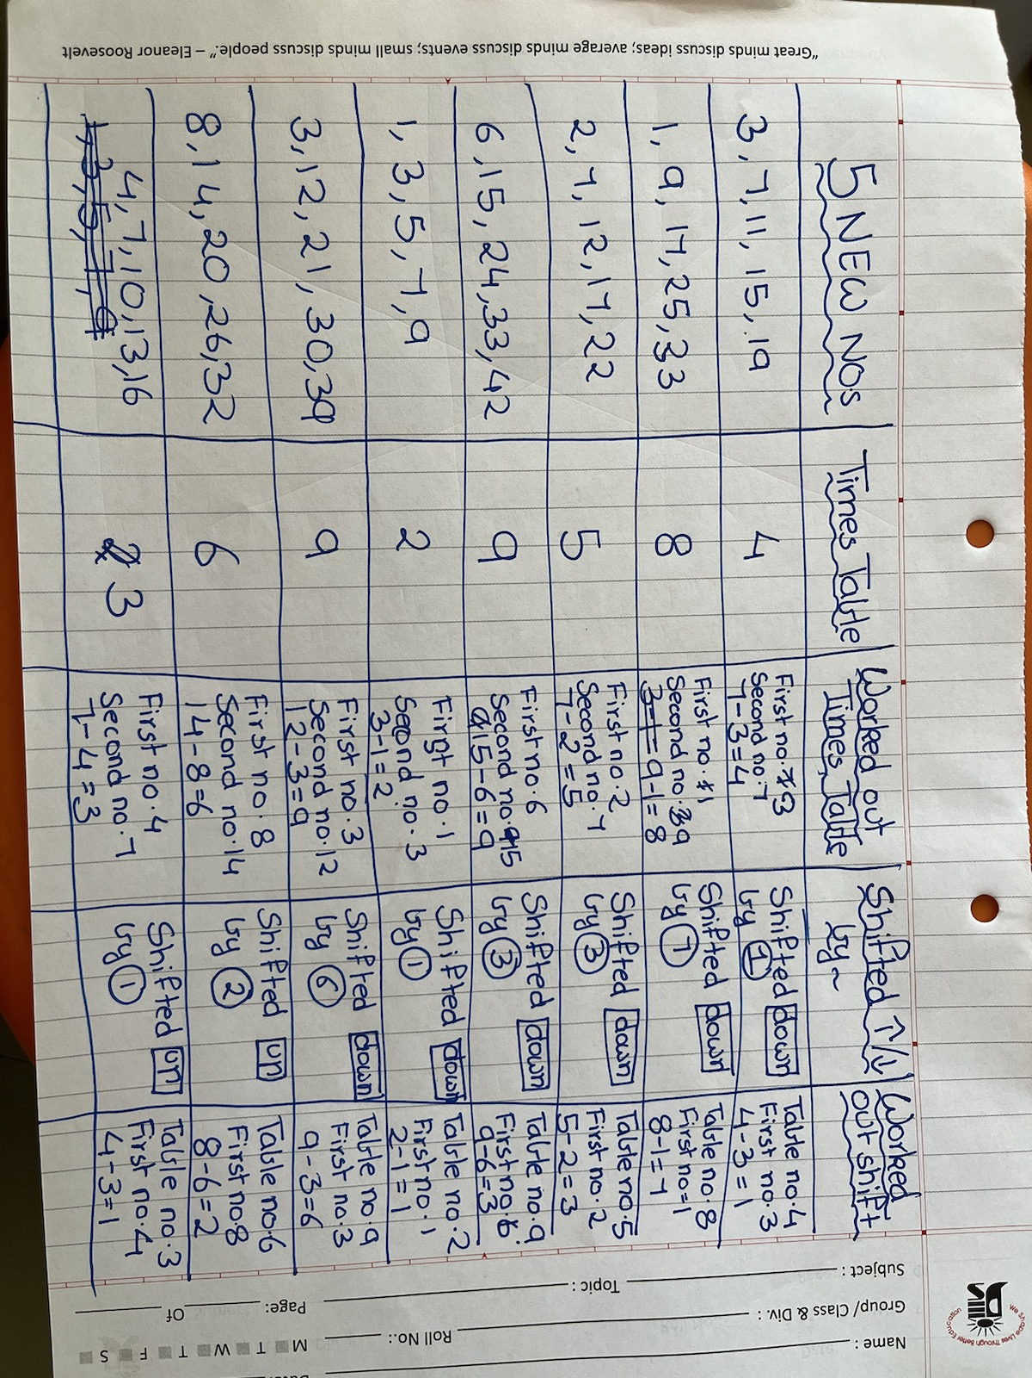
Below 9 images are from Pranathis work:
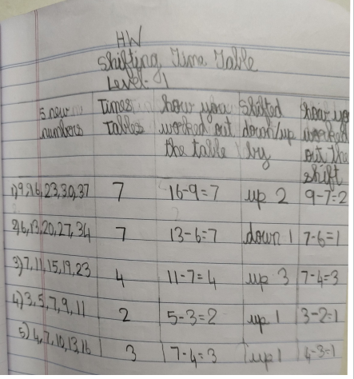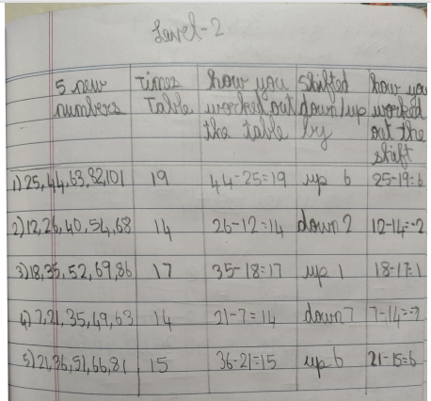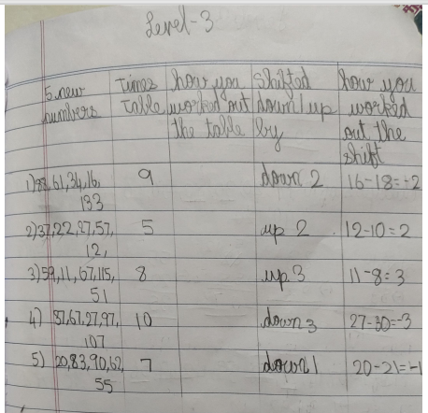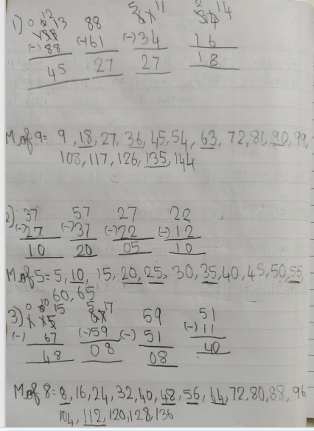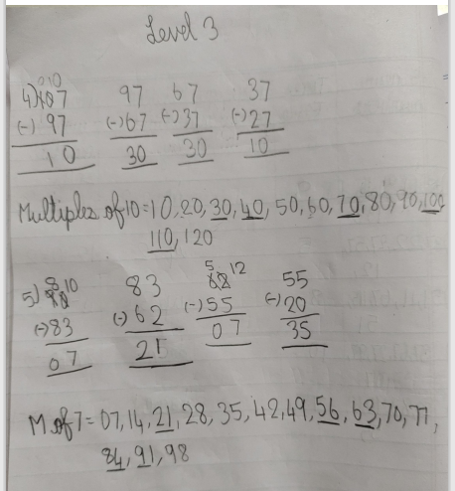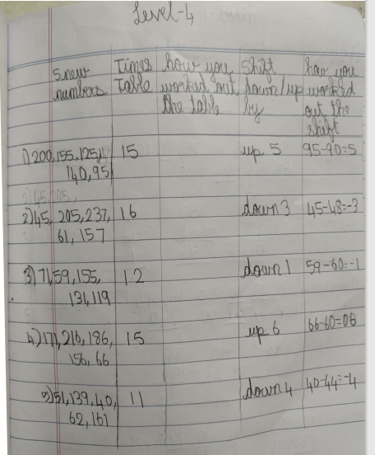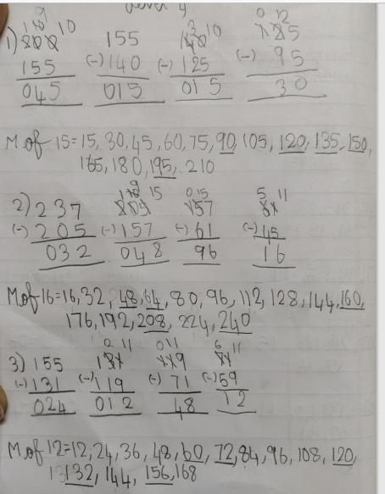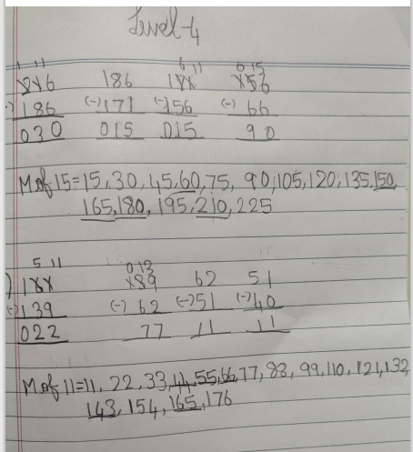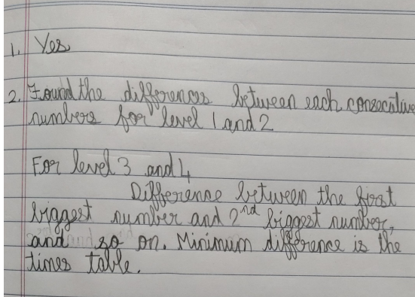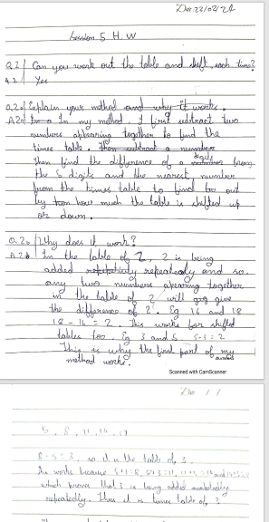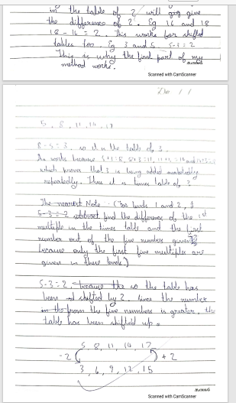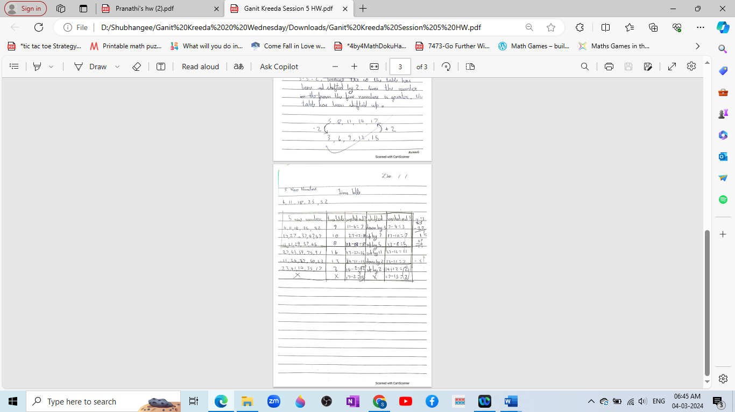
Last 3 images show Anathjith’s work.

