Cyclic Quadrilaterals
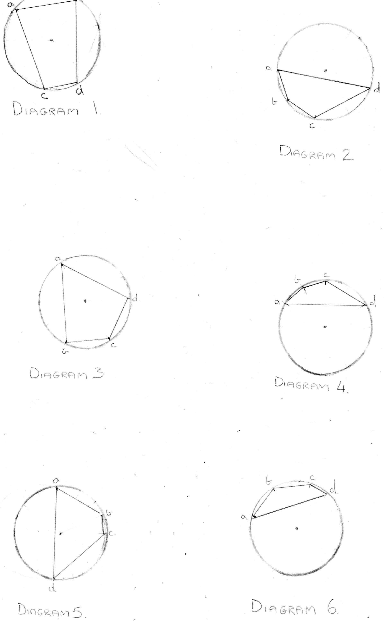
The sum of the angles at opposite vertices of a cyclic quadrilateral is 180 degrees. This is the same for all cyclic quadrilaterals, regardless of the positioning of the centre dot. For example:
- On a circle with nine points;
b

- On a circle with twelve points;

- On a circle with fifteen points;

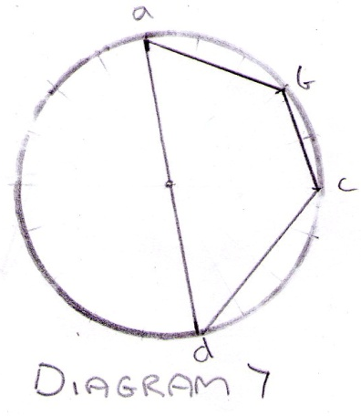
- On a circle with eighteen points;
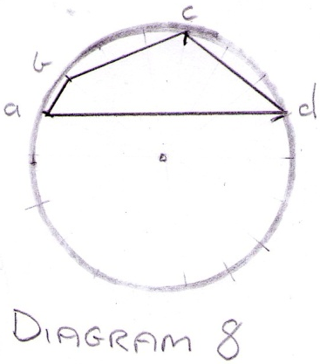

These results show that the sum of angles on opposite vertices of a cyclic quadrilateral equals 180˚, even when the centre dot is not inside the quadrilateral. Proof of this can be seen in diagrams 2, 4, 6 and 8.

In diagram 1, a (80˚) + d (100˚) =180˚ and b (80˚) + c (100˚) = 180˚.
In diagram 2 (the centre dot isn’t in the quadrilateral) a (60˚) + c (120˚) =180˚ and b (140˚) + d (40˚) =180˚.

In diagram 3, a (60˚) + c (120˚) =180˚ and b (90˚) + d (90˚) = 180˚.
In diagram 4 (the centre dot isn’t in the quadrilateral) a (45˚) + c (135˚) =180˚ and b (150˚) + d (30˚) =180˚.
In diagram 5, a (60˚) + c (120˚) =180˚ and b (132˚) + d (48˚) = 180˚.
In diagram 6 (the centre dot isn’t in the quadrilateral) a (36˚) + c (144˚) =180˚ and b (132˚) + d (48˚) =180˚.
In diagram 7, a (60˚) + c (120˚) =180˚ and b (130˚) + d (50˚) = 180˚.
In diagram 8 (the centre dot isn’t in the quadrilateral) a (60˚) + c (120˚) =180˚ and b (140˚) + d (40˚) =180˚.

