Cyclic Quadrilaterals solution by Shaunak
Can you work out the angles in your triangles?
Ans: The angles of the four triangles are:
40, 70, 70
80, 50, 50
120, 30, 30
160, 10, 10
I drew five quadrilaterals. These are the quadrilaterals and their angles:

Can you work out the angles of your quadrilaterals?
Quadrilateral 1:
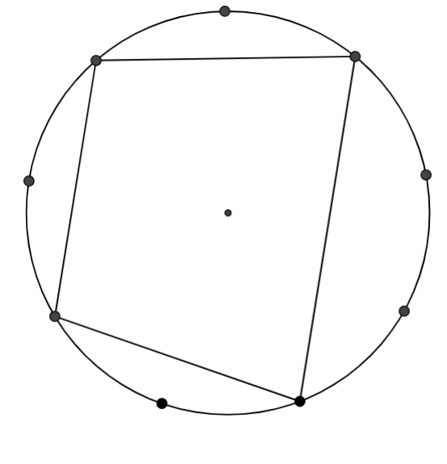
Finding the angles:
I drew 4 triangles inside it. This is how it now looked:
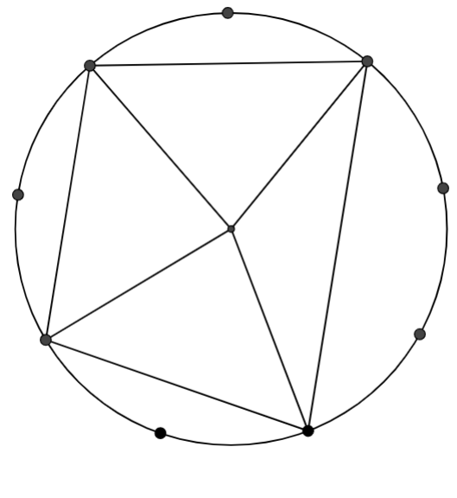
I knew the angles of the four triangles. So, I added up the angles in each corner.
In the order of top left, top right, bottom right, bottom left, the angles are 100, 80, 80, 100.
Quadrilateral 2:
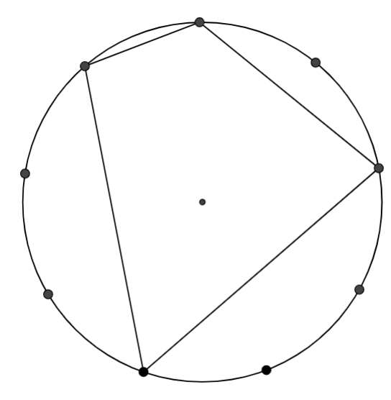
Finding the angles:
I drew 4 triangles inside it. This is how it now looked:
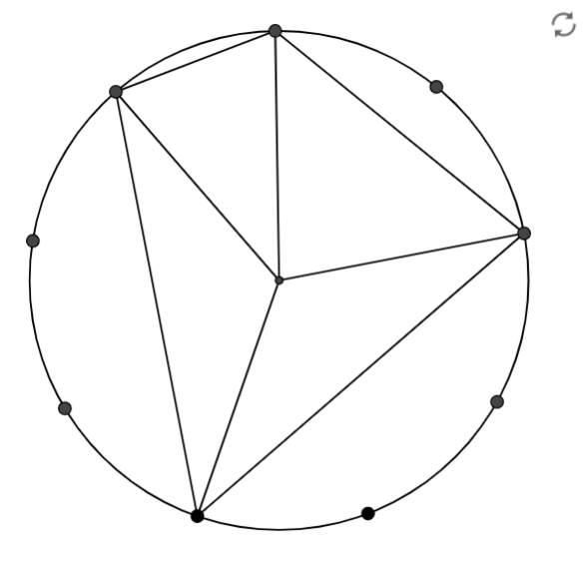

I knew the angles of the four triangles. So, I added up the angles in each corner.
In the order of top left, top right, bottom right, bottom left, the angles are 100, 120, 80, 60.

Quadrilateral 3:
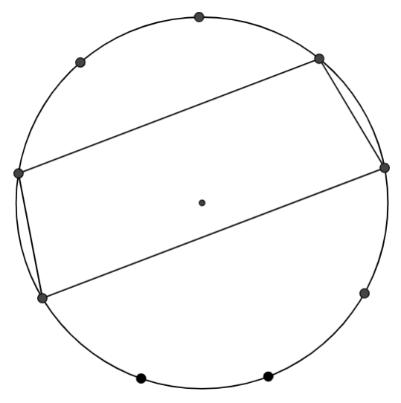

Finding the angles:
I drew 4 triangles inside it. This is how it now looked:

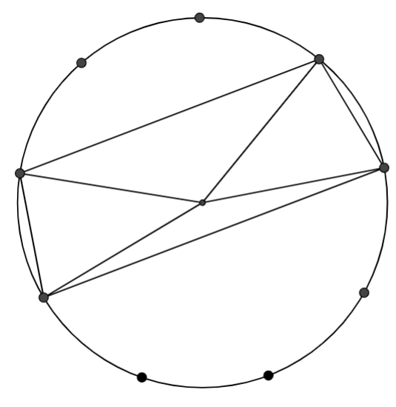

I knew the angles of the four triangles. So, I added up the angles in each corner.
In the order of top left, top right, bottom right, bottom left, the angles are 100, 100, 80, 80.

Quadrilateral 4:
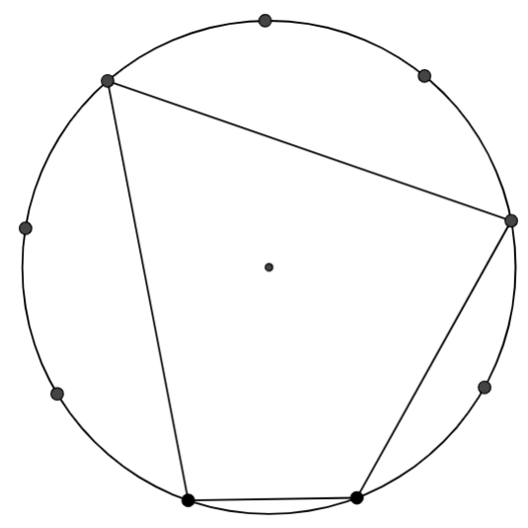

Finding the angles:
I drew 4 triangles inside it. This is how it now looked:
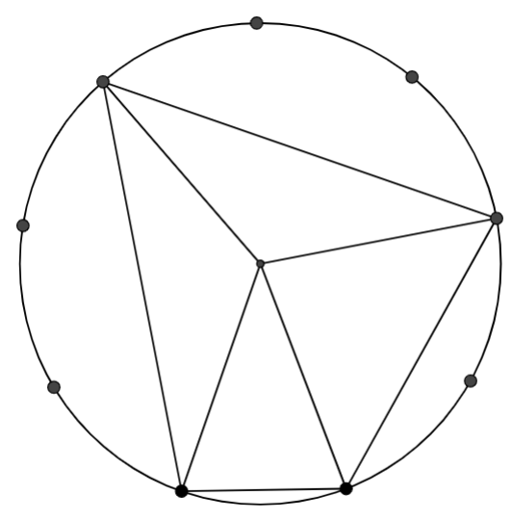

I knew the angles of the four triangles. So, I added up the angles in each corner.
In the order of top left, top right, bottom right, bottom left, the angles are 60, 80, 120, 100.

Quadrilateral 5:
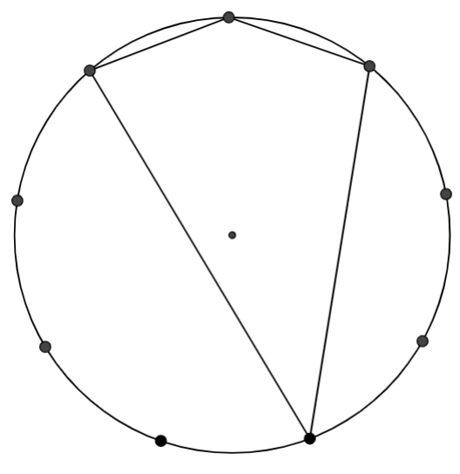

Finding the angles:
I drew 4 triangles in its inside. This is how it now looked:
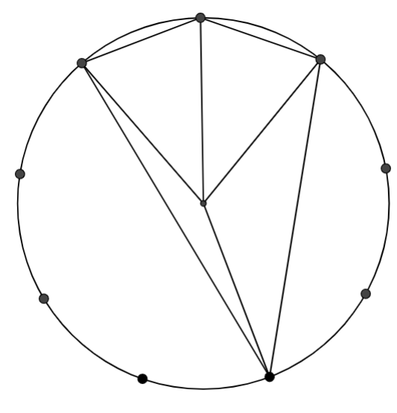

I knew the angles of the four triangles. So, I added up the angles in each corner.
In the order of top left, top right, bottom right, bottom left, the angles are 80, 140, 100, 40.

I observed that the sum of opposite angles will be 180.
This must work for any number of dots because even if the number of dots change, the quadrilateral’s properties won’t change.

