Joshua 11.1.23 – Solving a systematic problem involving prime numbers

Joshua attempted the “Sticky Numbers” problem from Nrich.org.
He began by experimenting with the number cards and making pairs of prime numbers and joined them to make a chain. He worked out that 16 could only be joined to 9 and so had to be at one end. This first attempt came to a dead-end:
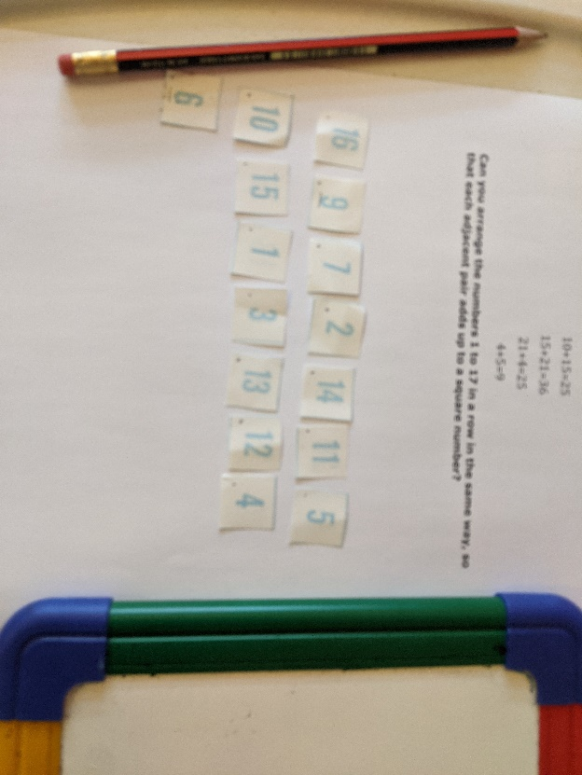

He then stopped and looked at the problem again and began to systematically look at other large numbers and how they would need to be paired. He found that they all needed to be paired with two particular lower numbers, and used this information to create a chain that worked.
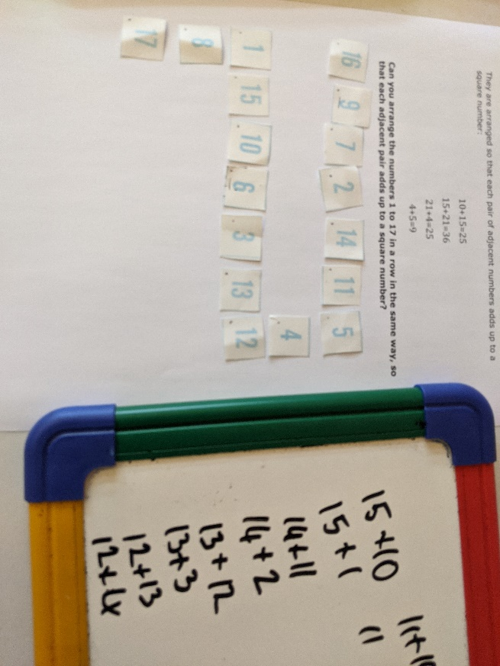
*Would such a chain be possible with any amount of numbers 1-x?

