Kite in a Square
Link: https://nrich.maths.org/6500

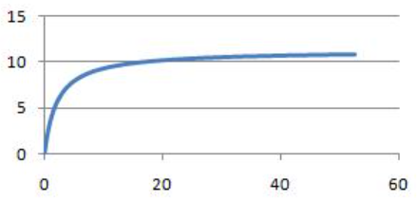
5) Vertical distance travelled by a small, heavy ball dropped from a plane.
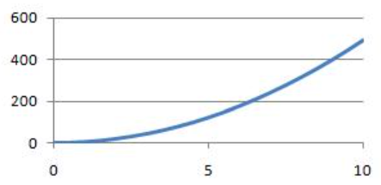
4) Volume (litres) against pressure (atmospheres) for 1 mole of an ideal gas at 0∘ C.
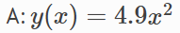
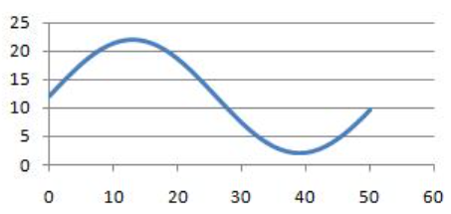
6) Rate of reaction of a catalysed reaction in terms of the concentration of reagent.

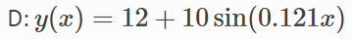
I have decided this because the y intercept is (12,0), and equation is (+12), The undulation up and down beginning at 0 suggest a sin equation.

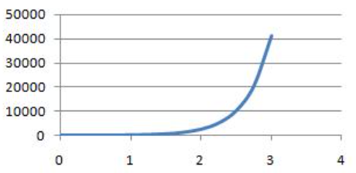
7) Number of rapidly dividing bacteria present in a food-rich environment, starting from a small initial sample.

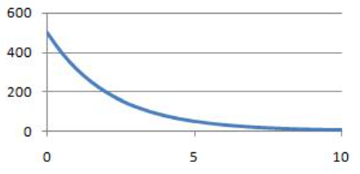
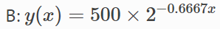
9) Model of the distance of the Earth from the sun in astronomical units.
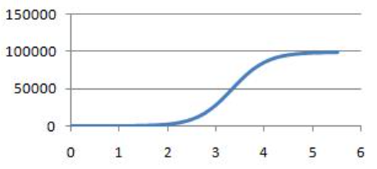
- Number of rapidly dividing bacteria present in a food-limited environment, starting from a small initial sample.

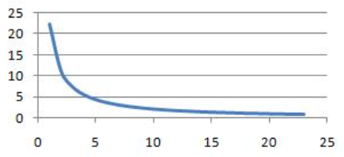
- Concentration in the blood of a drug following an injection.

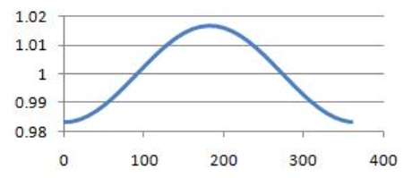
8) Hours of daylight per day in a town in the far northern hemisphere.

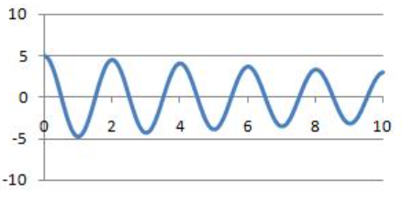
- Angle of oscillation of a real pendulum of length 1m in air.

