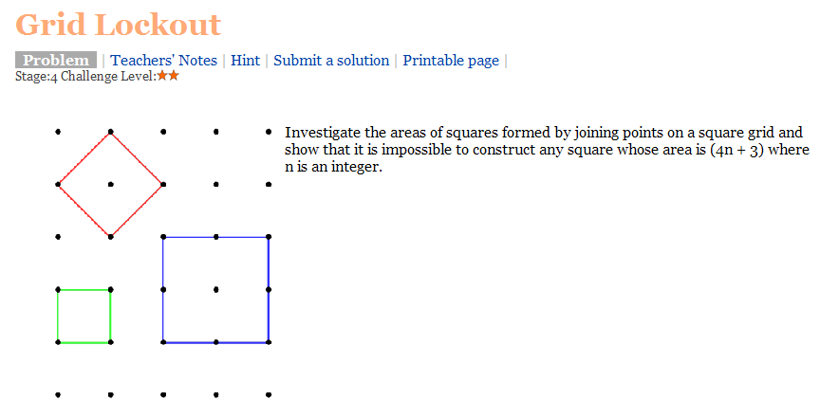
Solution
It is impossible to have a square whose area is (4n+3) as all square numbers when divided by 4 have remainder of either 0 or 1 as shown below. No square number divided by 4 is left with a remainder of 3.
Number | Squared | Divided by 4
2 | 4 | =1 rem 0
3 | 9 | =2 rem 1
4 | 16 | =4 rem 0
5 | 25 | =6 rem 1
6 | 36 | =9 rem 0
7 | 49 | =12 rem 1
8 | 64 | =16 rem 0
9 | 81 | =20 rem 1
10 | 100 | =25 rem 0
11 | 121 | =30 rem 1
12 | 144 | =36 rem 0
13 | 169 | =42 rem 1
14 | 196 | =49 rem 0
15 | 225 | =56 rem 1

