Can They Be Equal?

Solution :

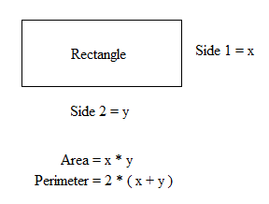

For Area = Perimeter
- x * y = 2 * ( x + y)
- y = (2 * x) / ( x – 2 )

Since sides should be non negative
For x > 2 we get the following graph for value of y.
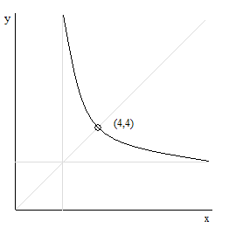

Conclusion :
There will be infinite many solution, with minimum length of a side greater than 2.

