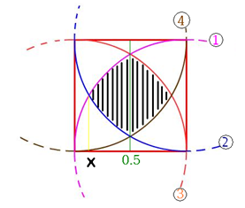
Ch.mPutting the picture on a Cartesian Grid, the lines of circles have following equations:

①: $y= \sqrt{1-{(x-1)}^{2}}$
②: $y= 1-\sqrt{1-{(x-1)}^{2}}$
③: $y=\sqrt{1-x^{2}}$
④: $y= 1-\sqrt{1-x^{2}}$

In order to find the shaded area, areas under the graphs ① and ② ranging from x to 0.5 on the x-axis are to be calculated. First, the intersection of the two graphs is found using technology:
$$∴Intersection of ① and ② ≑0.1339746$$
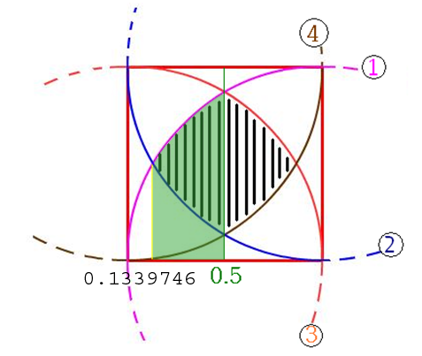

Using technology for the intergration, the area of green-shaded part under graph ① is calculated:
$$\int_{0.1339746}^{0.5}{\sqrt{1-{(x-1)}^{2}}} dx \\ ≑0.25962167$$

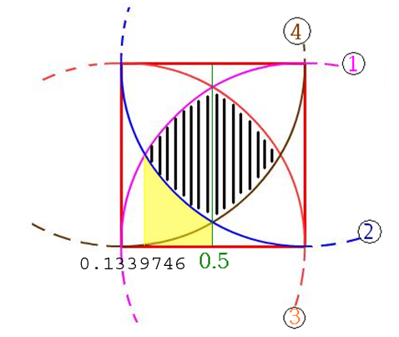
Using the same method, the area of yellow-shaded part under graph ② is calculated:
$$\int_{0.1339746}^{0.5}{1-\sqrt{1-{\left(x-1\right)}^{2}}} dx \\ ≑0.10208046$$

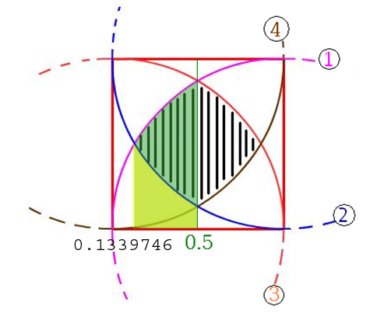
$$∵Green shaded area – Yellow shaded area \\ = half of the black shaded area$$

Therefore,
$$half of the black shaded area \\ ≑0.25962167- 0.10208046 \\ ≑0.15754121$$
Thus,
$$the whole black shaded area \\ ≑0.15754121×2 \\ ≑0.31508242$$

