Nrich Solution for M, M and M

This task of M, M and M was taken for 2 sessions with a group of 15 students in Ganit Kreeda, Vicharvatika, India by Shubhangee(facilitator).

The names of the students are:
Ahana, Ananthajith, Dhruv, Sehar, Saanvi, Nikhil, Insiya, Inaaya, Ishaan, Ishanvi, Sanat, Abhay, Karthik, Vishnuvardhan, Rudra.

Kids worked systematically to find all possible solutions.
Mean means Average.
Median means middle number when arranged in order.
Mode means most common/frequently used number.

Ahana’s work is attached below.

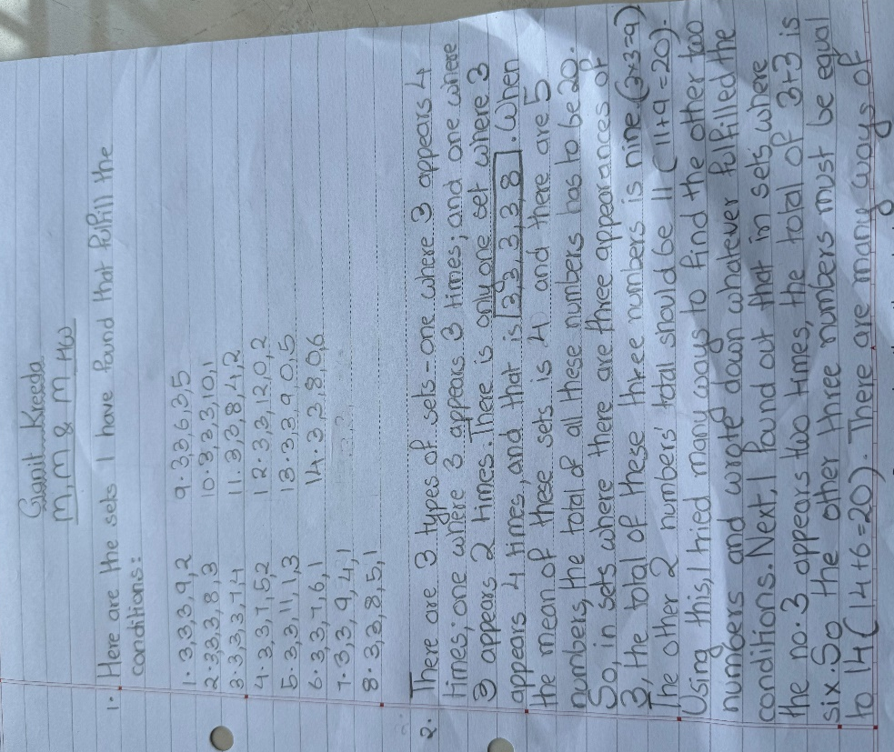
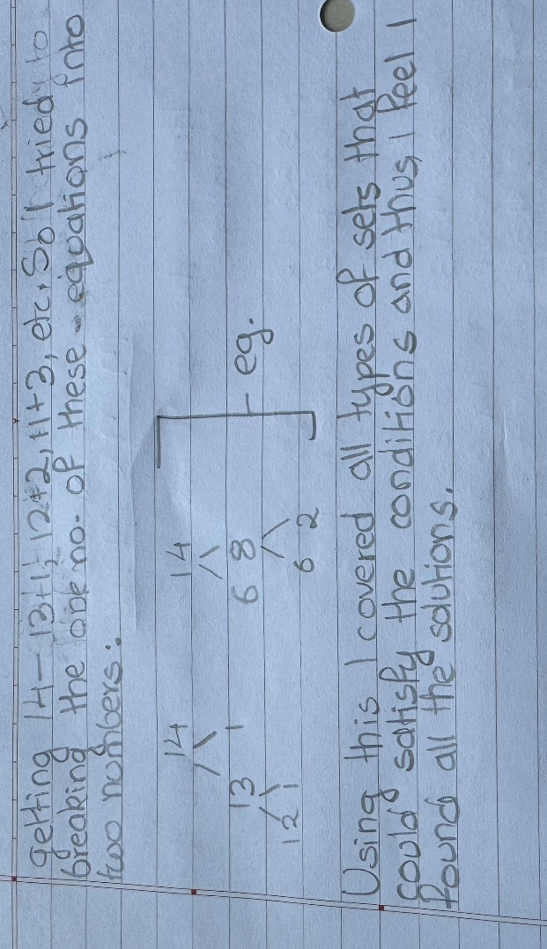

Here is Nikhil’s work:

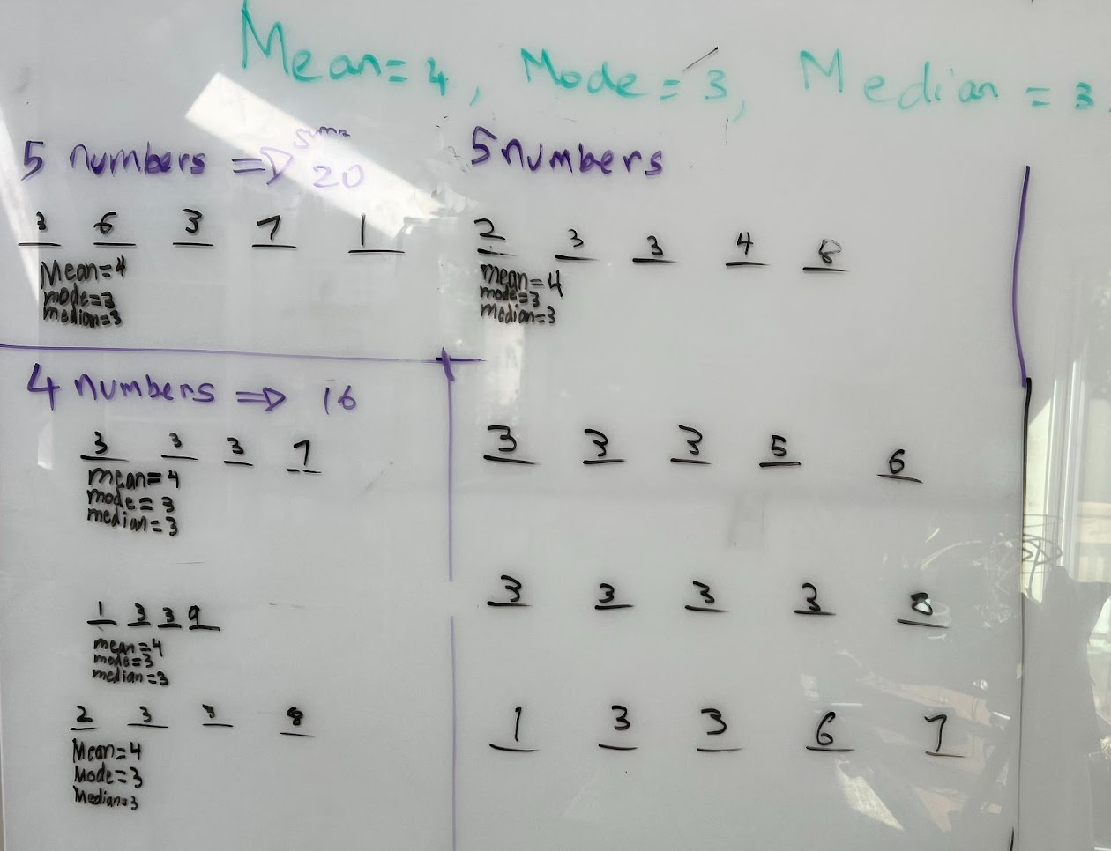

Here is Abhay’s work:
- Can you find all the different sets of five positive whole numbers that satisfy these conditions?

Set 1: 1 3 3 4 9
Set 2: 2 3 3 3 9
Set 3: 1 3 3 3 10
Set 4: 3 3 3 4 7
Set 5: 3 3 3 3 8
Set 6: 1 2 3 3 11
Set 7: 0 3 3 5 9
Set 8: 0 2 3 3 12
Set 9: 0 3 3 4 10
Set 10: 0 1 3 3 13
Set 11: 0 3 3 6 8
Set 12: 0 3 3 7 7

The problem suggests the set is made up of 5 positive whole numbers which means we can include 0. The parameters of this problem suggest it has to take 5 numbers to add up to 20 because the mean/average is 4. The mode is mentioned to be 3 which means that the number 3 is the most common number and it has to appear more than once in the sequence. The third clue says that the median is 3 which means the middle number in each set has to be 3. Then in my mind I tried to figure out all the sets that match this criterion. I was able to find 12 such sets.

Here is Sehar’s Work:

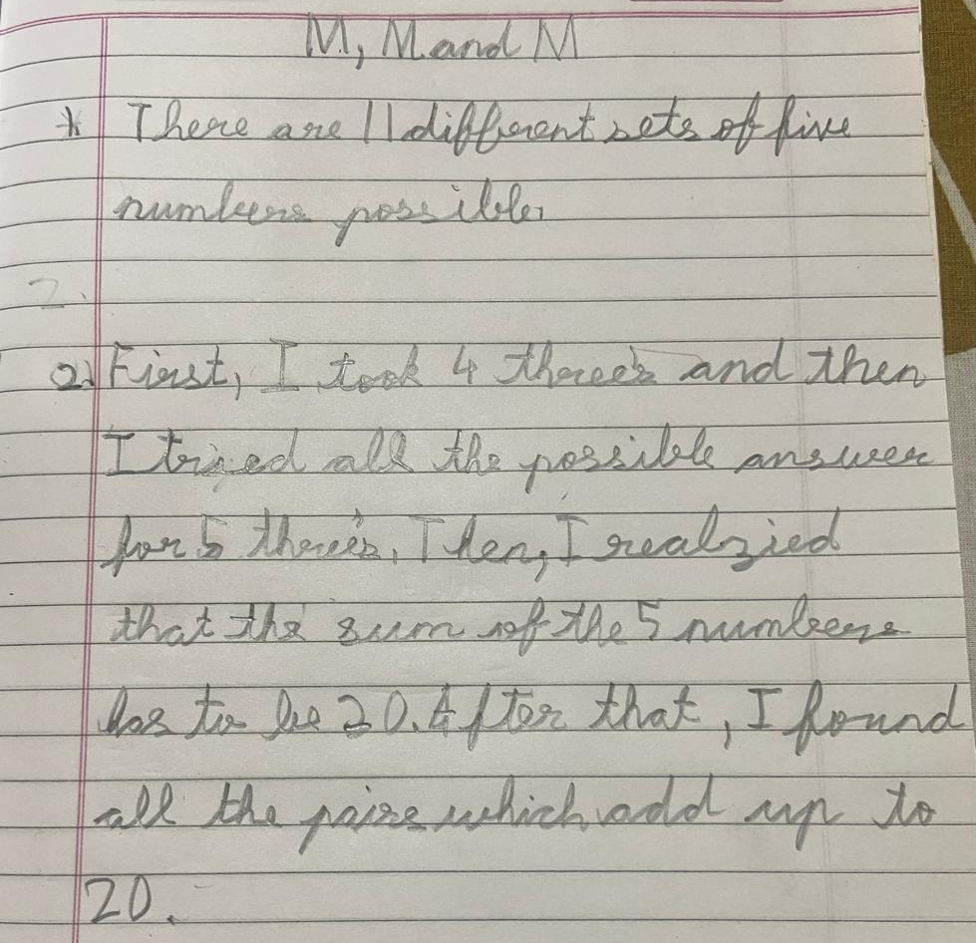

This is ishaan’s work:

I found them by sum of nos. Is 20 - mean is 4 and 4*5 is 20. 3 is mode so there will be 3 threes or 2 threes. So I calculated the remaining number combination.

10,1,3,3,3
9,2,3,3,3
8,3,3,3,3
7,4,3,3,3
6,5,3,3,3
11,2,1,3,3
9,4,1,3,3
8,5,1,3,3
7,6,1,3,3
2,4,8,3,3
2,5,7,3,3

This is Anathajith’s Solution along with explanation.

- Can you find all the different sets of five positive whole numbers that satisfy these conditions?
Ans Yes there are 9 sets of Positive Integers that satisfy these conditions.
They are given Below:
1,2,3,3,11
1,3,3,6,7
1,3,3,5,8
1,3,3,4,9
2,3,3,5,7
2,3,3,4,8
1,3,3,3,10
2,3,3,3,9
3,3,3,3,8

- Can you explain how you know you've found them all?
Ans: Suppose that when you arrange the five numbers in ascending order you get the number: a , b , c , d , e.
For Mean = 4 to be true, (a+b+c+d+e) divided by 5 must be 4.
Which Implies that 4 x 5 = a+b+c+d+e = 20
For the Median to be 3, c must be equal to 3. Median = 3 => c = 3
For Mode to be 3, other than c either b or d must be =3. Mode = 3 => c, b or d = 3 at minimum.
Note: All a , b , c ,d and e cannot be 3 because 3 x 5 is not = 20

Case 1: c=3, d=3
a , b , c , d , e
| | | | | Only Possibility for this Case.
1 2 3 3 11
Case 2: b=3, c=3
a , b , c , d , e
| | | | |
1 3 3 6 7
1 3 3 5 8 5 Possibilities
1 3 3 4 9
2 3 3 5 7
2 3 3 4 8
Case 3: b=3, c=3, d=3
a , b , c , d , e
| | | | |
1 3 3 3 10 2 Possibilities
2 3 3 3 9

Case 4: a=3, b=3, c=3
a , b , c , d , e
| | | | |
3 3 3 5 6 2 Possibilities
3 3 3 4 7

Case 4: a=3, b=3, c=3, d=3 Only Possibility for this Case.
3 3 3 3 8

Note: The case where b, c, d and e are 3 is not possible because ‘a’ would have to be less than 3 and if it was, the sum wouldn't be 20.

Therefore, Total Number of possibilities = 1 + 5 + 2 + 2+1 = 11

Later in the session kids worked collaboratively and their thinking is summarised here. Together they found 17 solutions, if 0 is allowed to use.

