NRich Find the Difference completed on 24/2/23
Year 2 Cromwell Community College, Primary Phase
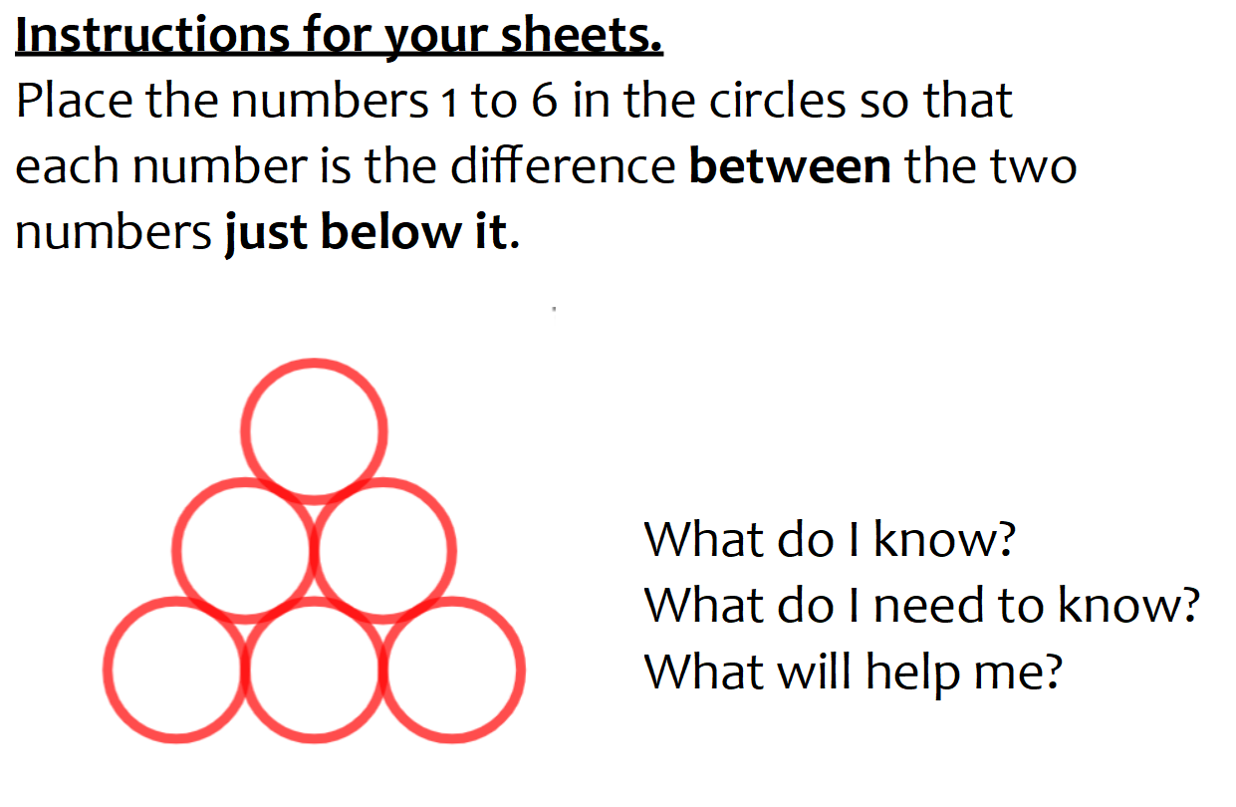
One boy suggested that 6 could not go at the top because the other numbers were less than 6. Another child said if they used their number bonds, they would not need to find the difference each time. Another child said crossing out the numbers each time would mean they only used each number once.

There was a little confusion about whether the numbers being subtracted had to be the correct way round. Once this was addressed, several children completed the problem.
A few children got very frustrated and so worked with adult support until they had completed the challenge together.
The children completed their work on a whiteboard and once they had found a solution, they copied it onto a pre-printed sheet.
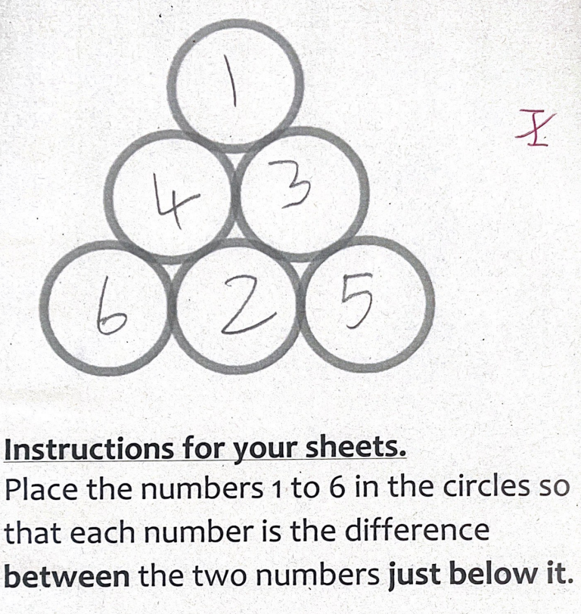
One of the children’s solution.

