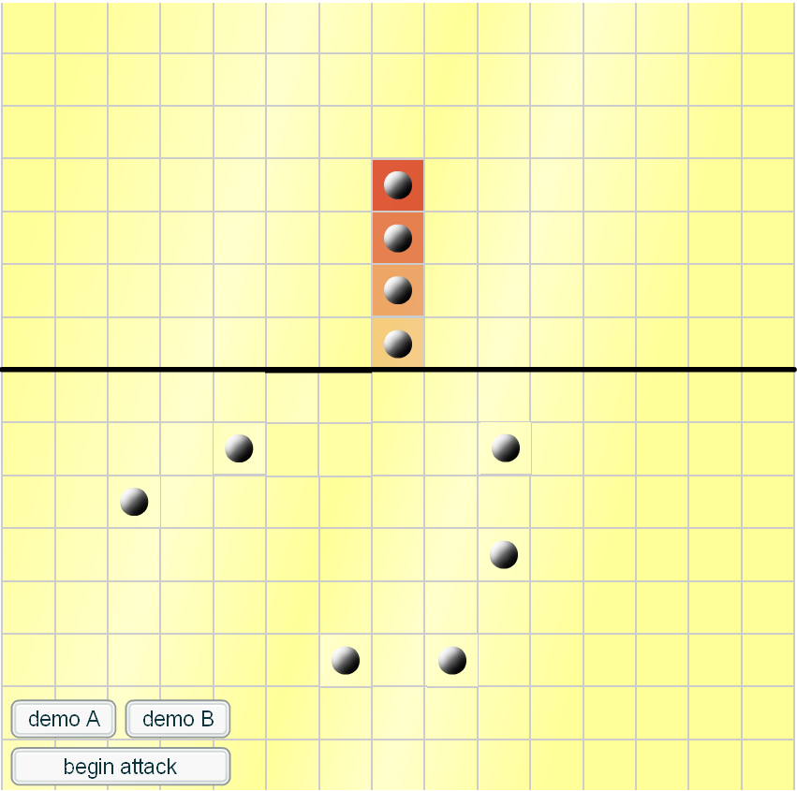

By Fred, Chester and Tom
We found the answer by using trail and error

