Quad in Quad – Solution
When a convex quadrilateral is drawn and the midpoints of each side is connected to create a new quadrilateral, then irrespective of what angles and shape the original quadrilateral has, the new quadrilateral created within it is a rhombus. So the new quadrilateral’s opposite sides are parallel and also have the same length.

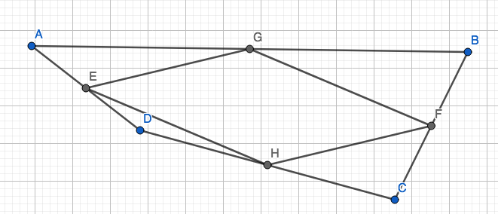

For example, the lines connecting the midpoints of AB and AD and the line connecting midpoints BC and CD are parallel to each other. (The same goes for the other sides, as it is a rhombus). This implies that the lines must have the same gradient.

The line EG was constructed by connecting the midpoint of AB and AD.

These are the calculations to find the gradient of EG:

$$AB=(\frac{x_{A+} x_{B}}{2},\frac{y_{A+} y_{B}}{2})$$
$$AD=(\frac{x_{A+} x_{D}}{2},\frac{y_{A+} y_{D}}{2})$$
$$Gradient of EG= \frac{\frac{y_{A+} y_{D}}{2}-\frac{y_{A+} y_{B}}{2}}{\frac{x_{A+} x_{D}}{2}-\frac{x_{A+} x_{B}}{2}}$$
$$= \frac{\frac{y_{D-} y_{B}}{2}}{\frac{x_{D-} x_{B}}{2}}$$
$$=\frac{y_{D-} y_{B}}{2}×\frac{2}{x_{D-} x_{B}}$$
$$=\frac{y_{D-} y_{B}}{x_{D-} x_{B}}$$
To find the gradient of the line connecting the midpoints of BC and CD (line HF), the same equation can be used.

This shows that the triangle AEG is similar to the triangle ADB. The line AG and AB have the same gradient and so does the line AE and AD. Thus the lines EG and DB must also have the same gradient, because they are similar triangles. This supports the equation created above, which essentially finds the gradient for DB.

Further, the lengths of the opposite sides of the new quadrilateral, within the original one, have the same length.

The calculations to find the length of the line EG are:

$$E:(\frac{x_{D}+x_{A}}{2},\frac{y_{D}+y_{A}}{2})$$

$$G:(\frac{x_{B}+x_{A}}{2},\frac{y_{D}+y_{A}}{2})$$

Using Pythagoras’ theorem to find distance between E and G:

$${\left(\frac{\left(x_{D}+x_{A}\right)-(x_{B}+x_{A})}{2}\right)}^{2}+{\left(\frac{\left(y_{D}+y_{A}\right)-(y_{B}+y_{A})}{2}\right)}^{2}={EG}^{2}$$
$${\left(\frac{\left(x_{D}-x_{B}\right)}{2}\right)}^{2}+{\left(\frac{\left(y_{D}-y_{B}\right)}{2}\right)}^{2}={EG}^{2}$$
$$\frac{{{\left(x_{D}-x_{B}\right)}^{2}+\left(y_{D}-y_{B}\right)}^{2}}{4}={EG}^{2}$$

$$\frac{\sqrt{{{\left(x_{D}-x_{B}\right)}^{2}+\left(y_{D}-y_{B}\right)}^{2}}}{2}=EG$$
Again, this is the same equation that can be used to find the length of the line HF, which is opposite to EG in the new quadrilateral.

Further, this shows that the length of EG is purely half of the length of DB. Similarly, the length HF would also be half of the length of DB and calculated with the same equation.

In the equation to find the length and gradient of the sides of the new quadrilateral, when simplifying the equation, the $x_{A}$ cancels out. This is why the equation is the same for the opposite sides.

For a concave quadrilateral, the same conclusion can be drawn as all the calculations for the gradient and length of the line remains the same. Thus the new quadrilateral in a concave quadrilateral is also a rhombus, just like in a convex quadrilateral.

