Factor-Multiple Puzzle Solution for Nrich

Myself Shubhangee (Facilitator) had worked collaboratively on ‘Factor-Multiple Puzzle’ with a group of 13 students of 3rd to 6th grade, in online mode, in ‘Ganit Kreeda’, Vicharvatika, India. The names of the students are:
Ahana, Sehar, Saanvi, Dhanvin, Aariz, Ananthjith, Vivaan, Sai, Pranathi, Paavani, Utkarsh, Tavish, Dhruv.
Kids collaboratively discussed and concluded that which 2 labels cannot go criss cross…meaning one on row and one on column.
Even & odd, as no number is even and odd.
No.s less than 20 & No.s more than 20.
Prime & Square numbers…as square number can’t be a prime number.
All other labels can be adjusted.
They also spotted that the only even prime is 2.
The only multiples of 3 and 5, which are also prime are 3 and 5 respectively.
Sehar shared this solution:

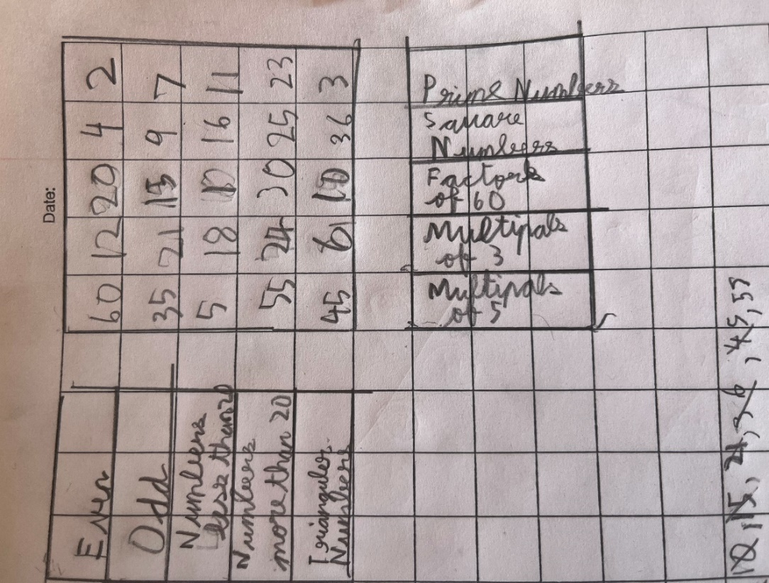
Pranathi sorted out all the numbers according to each category as shown and found the solution.
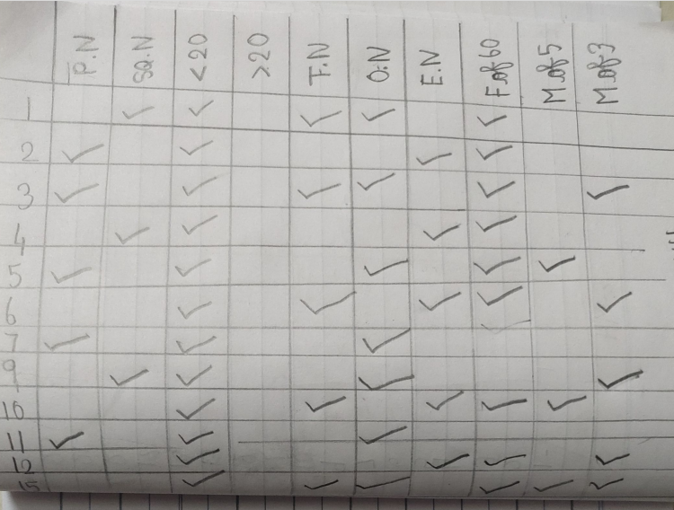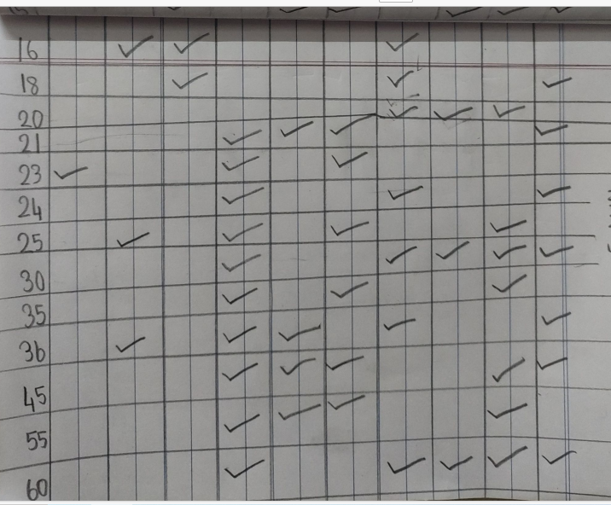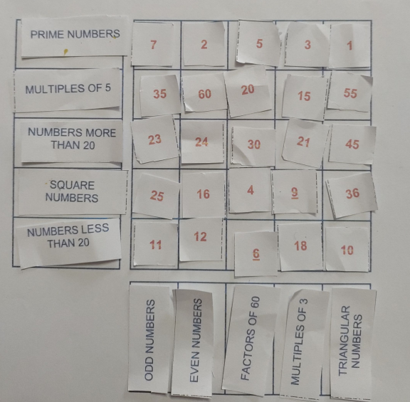
Ananthajith’s work here shows his systematic and ordered thinking.
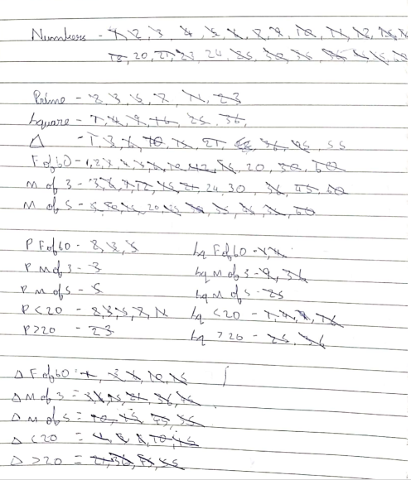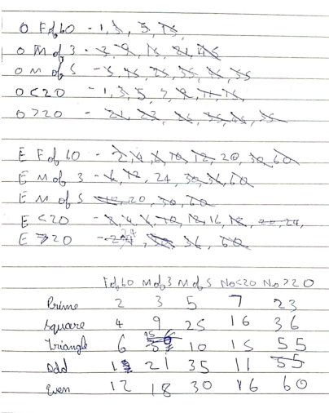
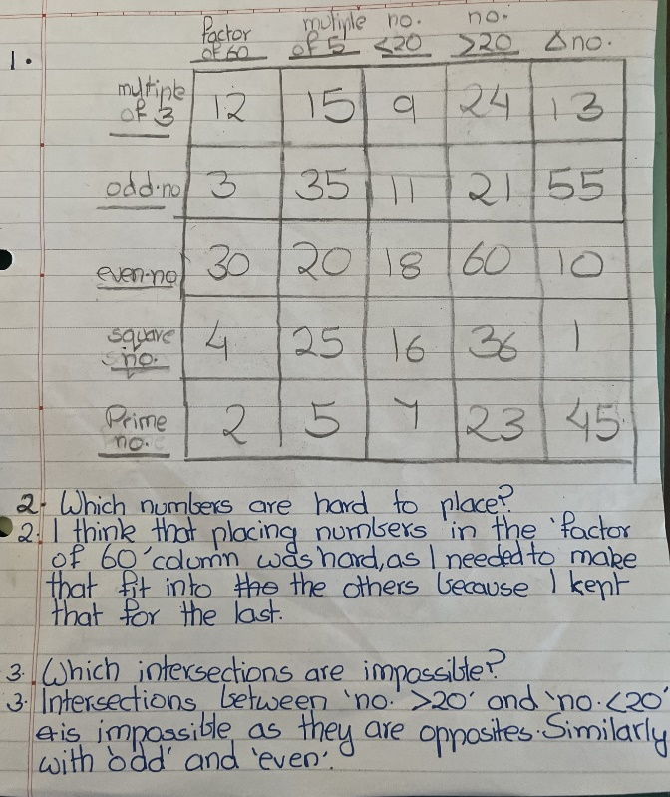
This is Ahana’s work.
