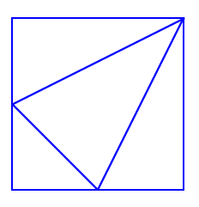
Fraction Fascination
(4) 3/8
(3) 1/8
(2) ¼
(1) ¼
Let us assume that this is a 100 unit square, and each side is 10 units. The two bottom vertices of number 4’s triangle are both in the midpoint of the sides. This means that the separation of the side leaves with 5 units. That means that triangle 1 has the base at 5 units and the height at 10 units. So the area of triangle 1 is: (10 x 5)/2 = 50 / 2 = 25 units². Triangle 2 is the same as 1, so triangle 2’s area is 25 units². 25 out of 100 is ¼ so 1 & 2 are ¼ of the total area.
3 is 5 units for its base and height so AREA₃ = (5 x 5) / 2 = 25 / 2 = 12.5 = 1/8 of the total area.
The only fraction left is 3/8 (because the ¼ equals 2/8), so triangle 4 is 3/8.

How is the 2nd shape made?
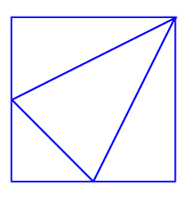
Like this (without the middle lines):

What is the shape that has been created in the middle of this larger square?
I see a rhombus in the middle.

What fraction of the total area of the large square does this shape take up?
When we look in the middle of the giant square I made above, we see a cross of lines in the middle. Notice how those lines make 4 triangles. Those triangles are exactly the same as triangle 1 and 2 that I labelled earlier. This means that each of those triangles is 25 units². So the total area of the rhombus is 100 units². Now, since we have two squares by two squares, the total area is (10 x 10) x 2 x 2 = 100 x 4 = 400 units². 100 units² out of 400 units² is ¼.

