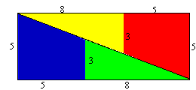
Doesn’t add up
b
a
Here, a = 8, b = 5, c = 3 and d = 5
c
d

If the line from the top left hand corner to the bottom right hand corner is a straight line, the yellow triangle and the red + yellow triangle are similar. Therefore the line on the yellow triangle measuring 8 (a) / the top line of the triangle measuring 13 (a+b)should be equal to the line which the triangle and trapezium share measuring 3 (c)/ the right hand side line of the rectangle measuring 5. But 8/13 does not equal 3/5, therefore that line is not a straight line. Therefore between the yellow and red shape, and the blue and green shape, there must be some space. By coincidence, it happens to equal 1, therefore the new shape is bigger.
c

