Set A
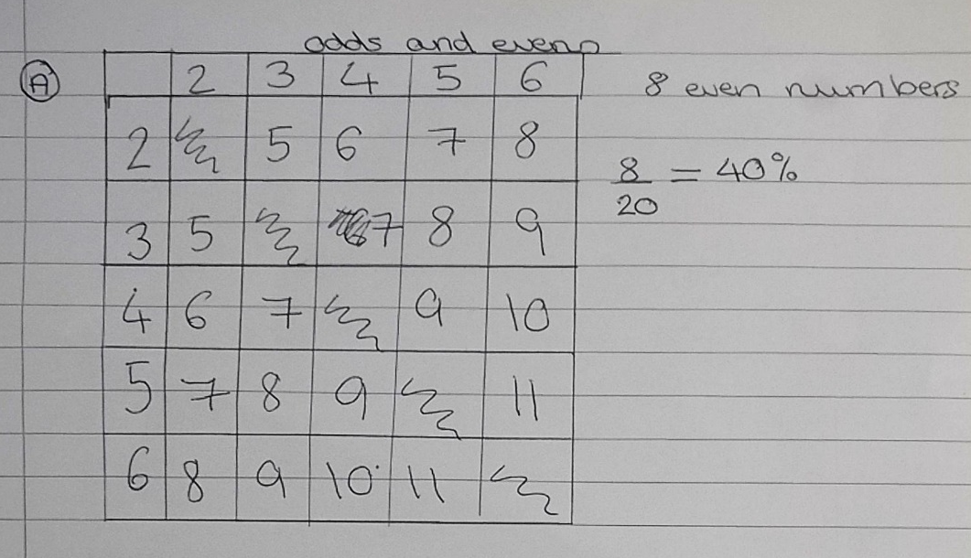

From the table we have worked out all the possible outcomes of the experiment. We have ignored the diagonals as we are choosing numbers without replacement.
Therefore, from the table we have 8 even numbers out of a possible 20 and so the probability of winning is 40%.

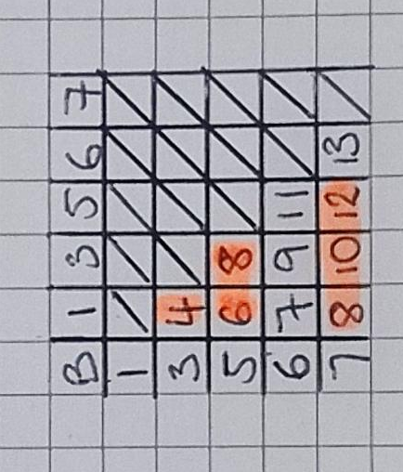
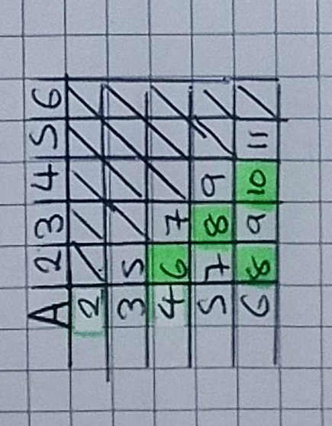
Set A and B

One group noticed that we only needed to use half of the table to work out the probabilities as the table is mirrored about the diagonal. From the first table we can see that using set A there are 4 even numbers out of a possible 10 and so the probability of winning is also 40%. Using a similar table for set B, we can see that there are 6 evens out of a possible 10. Therefore, the probability of winning is 60%.

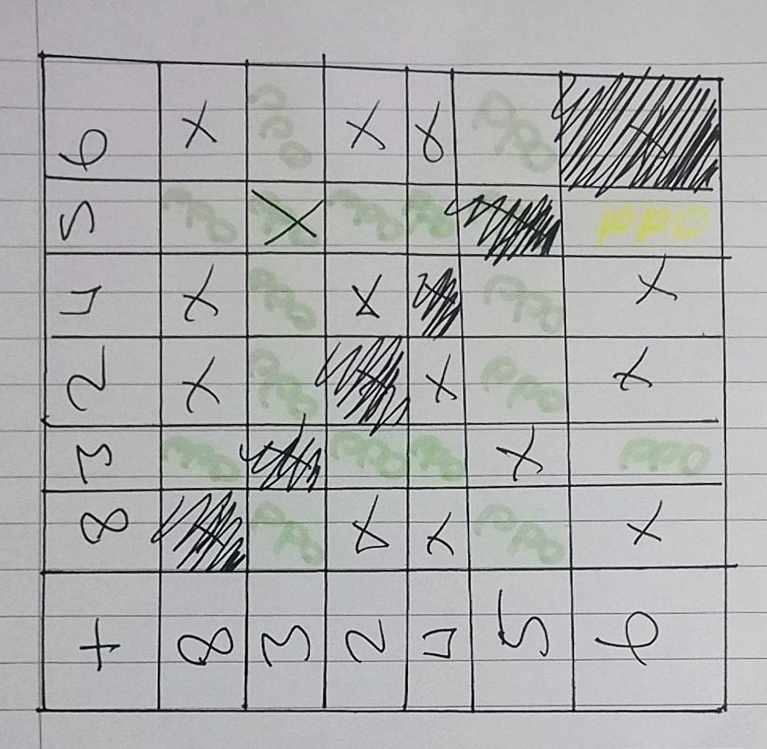
Set C

Using a similar method, we found out what all the outcomes were using set C. The diagonals are again ignored as we cannot pick the same number twice. The outcomes resulting in odd numbers are labelled ‘odd’ and the outcomes resulting in an even number is labelled with an ‘x’. From this we can see that there are 14 even outcomes and 16 odd outcomes. Therefore, we have 14 winning outcomes out of a possible 30 and so the probability of winning is 46.7%.

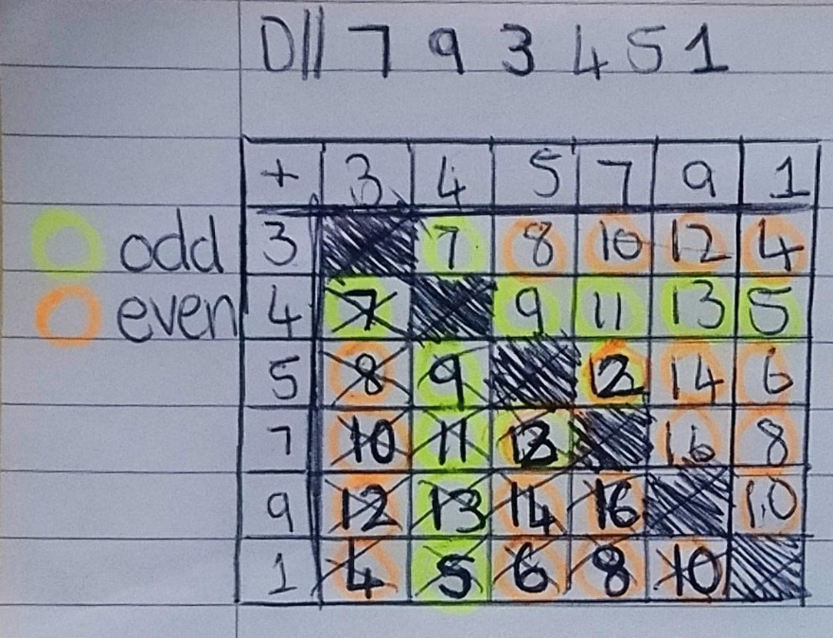
Set D

Above is a table representing the sample space diagram for set D. From here we can see that there are 20 even outcomes and 10 odd outcomes. Therefore, we have 20 winning outcomes from a possible 30 and so the probability of winning is 66.7%.

Overall, as set D gives us the greatest probability of winning, we would choose to play with set D to maximise the chances of winning.

