Final Challenge

When I was working through this question I perceived that:

- When triangles have their bases on the same line and the shared side (making the height same) the area of the triangles and the length of the bases of their triangles are in the same ratio.
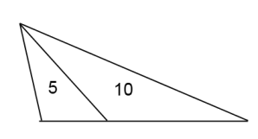
Here if the area was 5 and 10, and I made the height as
- 2cm the base of the 1st tri will be 5 and the base of the 2nd tri will be 10
- 5cm the base of the 1st tri will be 2 and the base of the 2nd tri will be 4
- 2.5 the base of the 1st tri will be 4 and the base of the tri 8
The lengths of the base is in the same ratio as the area of triangle
5:10; 2:4; 4:8 = 5:10

1st tri 2nd tri

OR
If the bases were 2 and 2.5 and I made the height:
- 2 the area will be 2 and 2.5
- 4 the area will be 4 and 5
- 10 the area will be 10 and 12.5
- 16 the area will be 16 and 20
Even if the height differs the ratio of the base lengths is the same as the ratio of the area
2 2.5

If the area of 2 triangles with their bases on the same line was given we could work out the base lengths using the ratio of the area, even if the heights are different --
Using this information I worked out the area of the quadrilateral
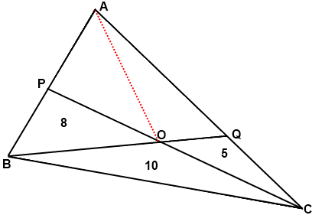

The area of the quadrilateral is 4cm²
I made the area of triangles as bases of 16:8 as the area was 10:5 to make the ratio the same. Now 16 is the height (or the shared side) of the area of the triangles 8 and 10 therefore I made the bases as 1:1.25 as the ratio of the area was 8:10. Then i studied AQCOP. The bases on the same line was in a ratio was 1.25:1 the area of the ratio had to be
5:4
- 5/1.25 = 4

8
16
1
1.25

