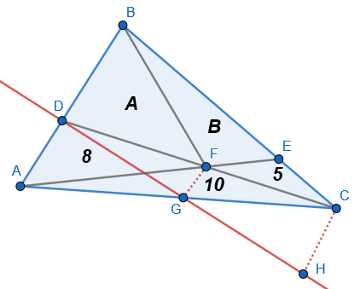
The diagram to the right shows the triangle, whose vertices have been labelled A, B and C. The lines DC and AE split the triangle into three smaller triangles of known area and a quadrilateral of unknown area. F is the intersection of these lines. BF splits BDFE into two triangles: DBF, which has area A, and BFE, which has area B. We wish to find A + B.
Firstly, consider triangles ADF and ADC. Let [XYZ] denote the area of triangle XYZ. We have [ADF] = 8 and [ADC] = 8 + 10 = 18. Since both triangles have the same base (AD), their perpendicular heights must be in the same ratio as their areas: 8:18, or 4:9. The red line in the diagram is perpendicular to AD at D, and G and H are the feet of the altitudes to it from F and C respectively. DG is the height of triangle ADF, and DH is the height of ADC, so DG:DH = 4:9. Now, we want to show that DG:DH = DF:DC, and we can do this with similar triangles. In triangles DGF and DHC, the angle at D is common and <DGF = <DHC = 90°, so they are similar (AA). It follows that DG:DH = DF:DC = 4:9. Furthermore, DF:FC = 4:5. We can repeat this process with triangles CEF and CEA to show that EF:EA = 1:3, so EF:FA = 1:2.
Now, triangles DBF and BCF share the same perpendicular height (the altitude from B to DC), so their areas are in the ratio of their bases. We know that DF:FC = 4:5, so:
$\frac{[DBF]}{[BCF]}=\frac{A}{B+5}=\frac{4}{5}$ , or 5A = 4B + 20 (*).
Additionally, FBE and ABF share the same perpendicular height (the altitude from B to AE), so their areas are also in the ratio of their bases. EF:FA = 1:2, so:
$\frac{[FBE]}{[ABF]}=\frac{B}{A+8}=\frac{1}{2}$ , or 2B = A + 8 (**).
We can now solve equations (*) and (**) as a pair of simultaneous equations. Doubling (**) and substituting it into (*) gives 5A = (2A + 16) + 20, or 3A = 36. Hence, A = 12. Substituting this into (**) gives 2B = (12) + 8 = 20, so that B = 10.
Finally, A + B = 12 + 10 = 22, so the area of the shaded quadrilateral is 22.

