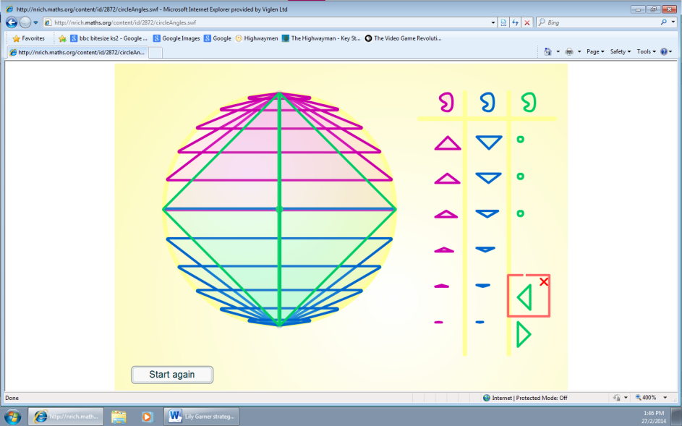
  - I started on the middle left and then dragged it to the middle right and then up to the top. I did it again but with one above the middle left and one above the middle right up to the top again and so on. For the bottom I did the same but at the bottom instead of the top. After I added the two big triangles by going from the middle left to the bottom and the top and same for the right.

