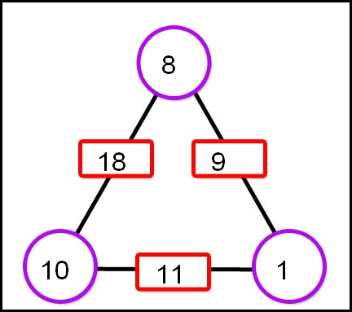

An arithmagon is a mathmathical equation that has 4 cirlces and 3 rectangles/square, each containing a number.The corner cirlces are connected together by lines, and along thse lines are the reectangles.In the rectangles are the sum of bother the circles the line it is one joins.
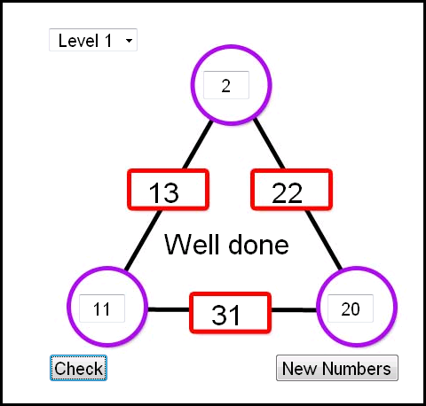
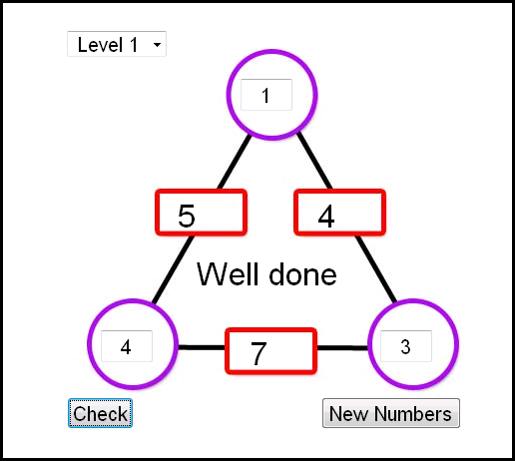
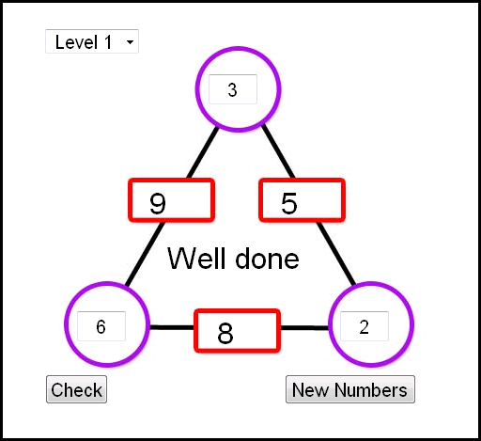
When you are given the square but not the corner cicrles, you must work out the corner circles. 3 e.gs:

The first thing I noticed was that all the corners added together equal half of all the rectangles added together.For the first one as an example:Corners=11 and rectangles=22. I will label the numbers on the vertices A,B and C and the the boxes D,E,F. To work out the vertices you add up D,E and F(22) and divide by 2(11).Then minus a rectangle from a the added total and that equals the corner circle;Total-D=B, Total-E= C and Total-F=A.
You can tell whether the vertices numbers will be positive by adding A,B and C, if this is smaller than any of the numbers it will be negative.
You can tell whether the numbers are going to be whole or not as if you add A,B and C together and it is odd, they will be fractions.

