It is the first time that I have seen this question, so I have decided to take the 2-D version treasure hunt first. My intuition told me that I should attempt the center of the map first. However, after a few attempts, I realised that choosing a center to start is not a good option.

The optimal way is to choose a corner to start, and it will take 3 guesses to find treasure at most. Also, I have realised that, if my first guest is at coordinate (0,0) and the program tells me distance is “C” then the treasure will lie on the x+y=C line. This would make sense, if we assume the treasure is at the coordinate of (x,y), and we take a guest at a coordinate of (a,b), and the program tells you the distance is C, then the treasure will locate on the relation |x-a|+|y-b|= C. for example, if you took (5,4) as a guess and the program tells you the distance is 3, then you know the treasure could be located in any integer set of the relation
|x-5|+|y-4|= 3. Now, notice that we could use algebra to solve the problem.

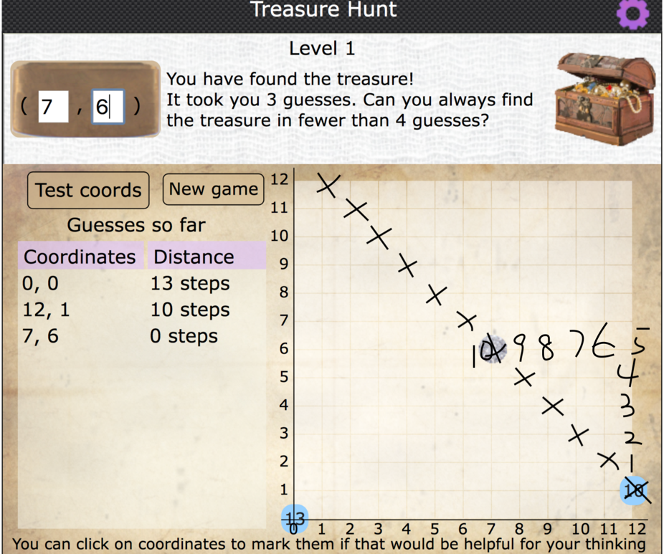
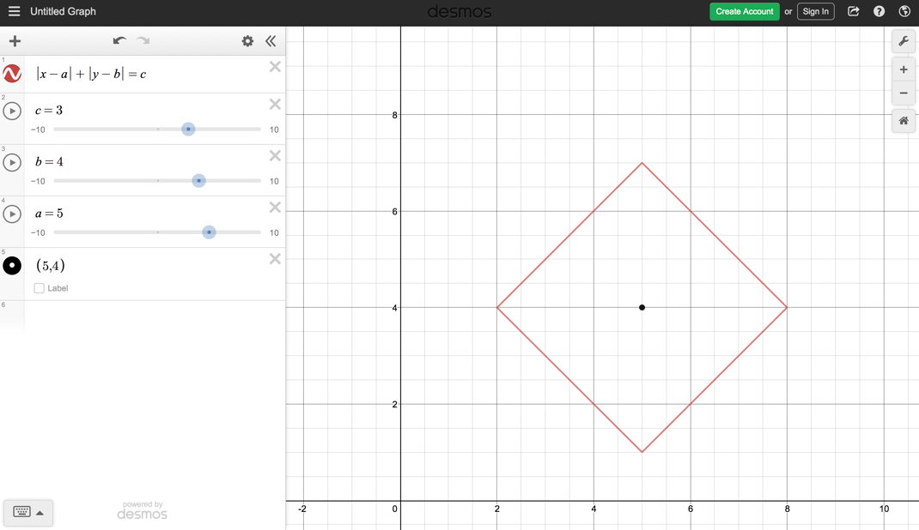(desmos)

Let’s turn back the 3-D version, we start with a concern coordinate as our first guess, for the sake of convenience, let’s pick (0,0,0) to start. Now, if the program tells us the distance is “C”, where “1 ≤ C ≤ 9”, then we can try (C,0,0) as our second guess. For example, if the distance from (0,0,0) is 7 steps, then we try (7,0,0) as the second guess. Now, assume the program told us the distance from (7,0,0) is 6 steps. From the above two information, we can come up with two equations.

|x - 0|+|y - 0|+|z - 0|=7 simplified to x + y + z = 7 (since x,y,z are all positive, |x|=x, …)
|x - 7| +|y - 0| + |z -0| = 6 simplified to -x + y + z = -1 (since (x-7) is negative, |x-7|=7 - x )

From x + y + z = 7
-x + y + z = -1
Solve the system equations, we get x = 4, y + z= 3

Now, try (4,3,0) for the third guess, (because the biggest possible value for now that y-coordinate could be is 3) and we were told treasure is only 2 steps away from (4,3,0). We can write down the third equation
|x-4|+|y-3|+|z|=2 and simplify that,
(3 - y) + z =2 ⇒ z – y = -1 (as x=4, |x-4|=0, y-3 is negative, since y < 3, |y – 3|= 3 – y )

From y + z= 3 and z – y = -1 , we can get y=2 z=1, and finally we find the treasure (4,2,1)

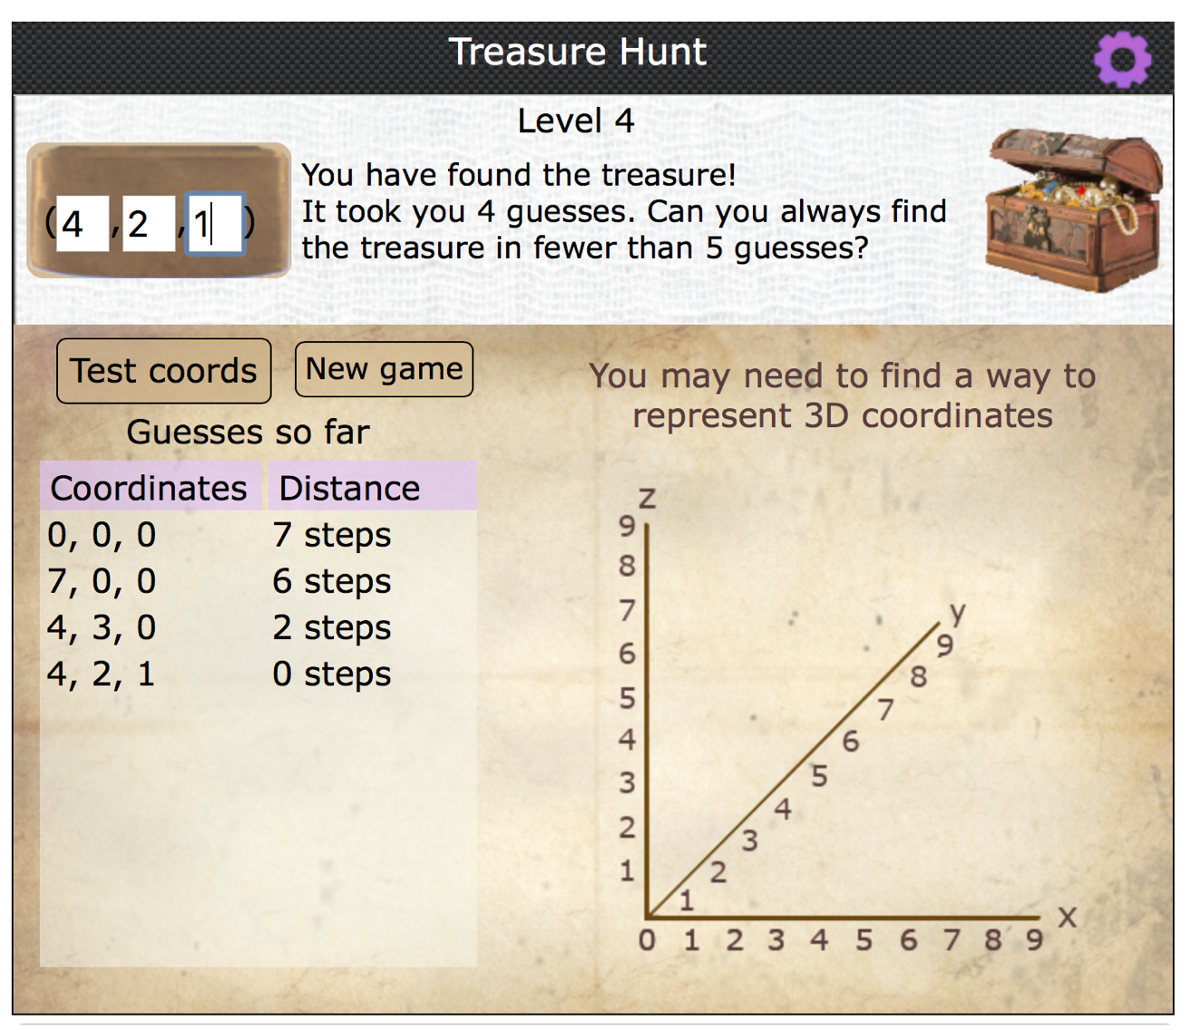
(example 1)
Method: Start with (0,0,0) for the first guest, and then for the next guesses, take a guess that is the biggest possible value for x-coordinate, and then y-coordinate. For example, if we were told that treasure is 6 steps away from (0,0,0), then guess (6,0,0) for the second guess. If it is 11 steps away from (0,0,0), then guess (9,2,0) for the second guess. If it is 20 steps away from (0,0,0), then guess (9,9,2).

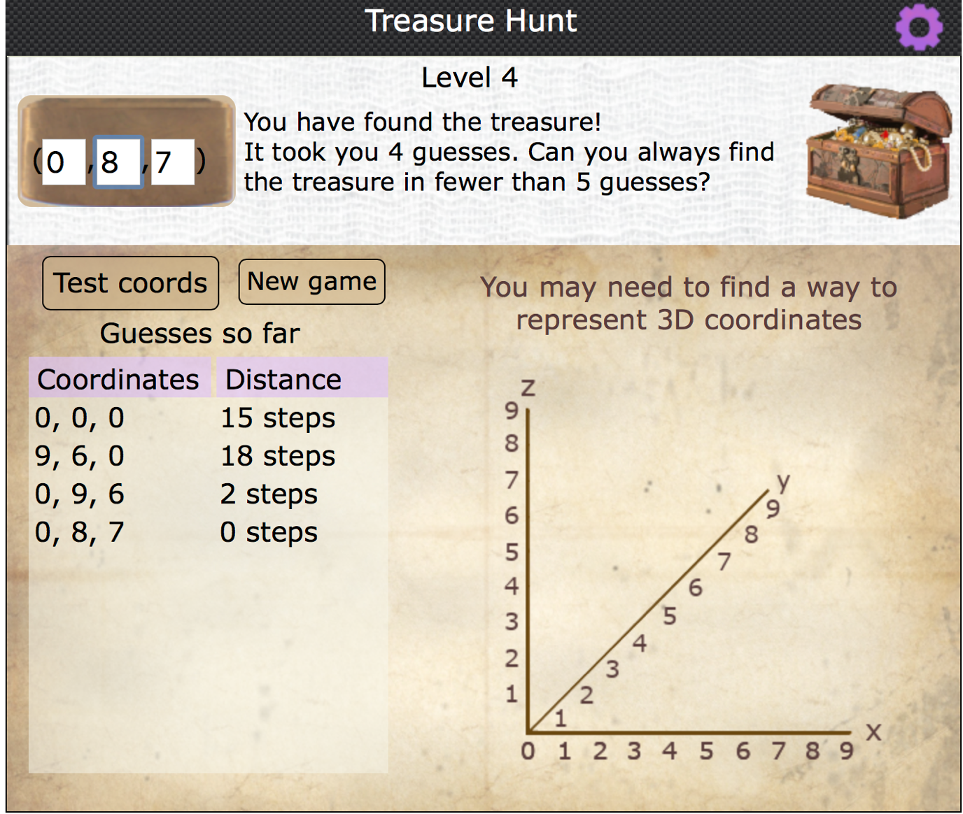

Another example
x + y + z =15 (from guess 1)

|x - 9| + |y – 6| + z = 18 (guess 2)

As (x-9) ≤ 0, since x ≤ 9, |x - 9|= 9 – x. For |y – 6|, assume it is equal to y – 6 first, and use it solve for x, and if the value for solved x is the integer in between 0 to 9, then |y – 6|= y – 6, otherwise |y – 6|= 6 – y. Then using the same method from example 1 to calculate z and y coordinates, we get (0,8,7). Only 4 guesses are required for finding the 3-D treasure.

By the way, using 3D Calculator from GeoGebra is a good way to visualize it. Also, I suppose that a 4-D treasure could also be found by using this method.

