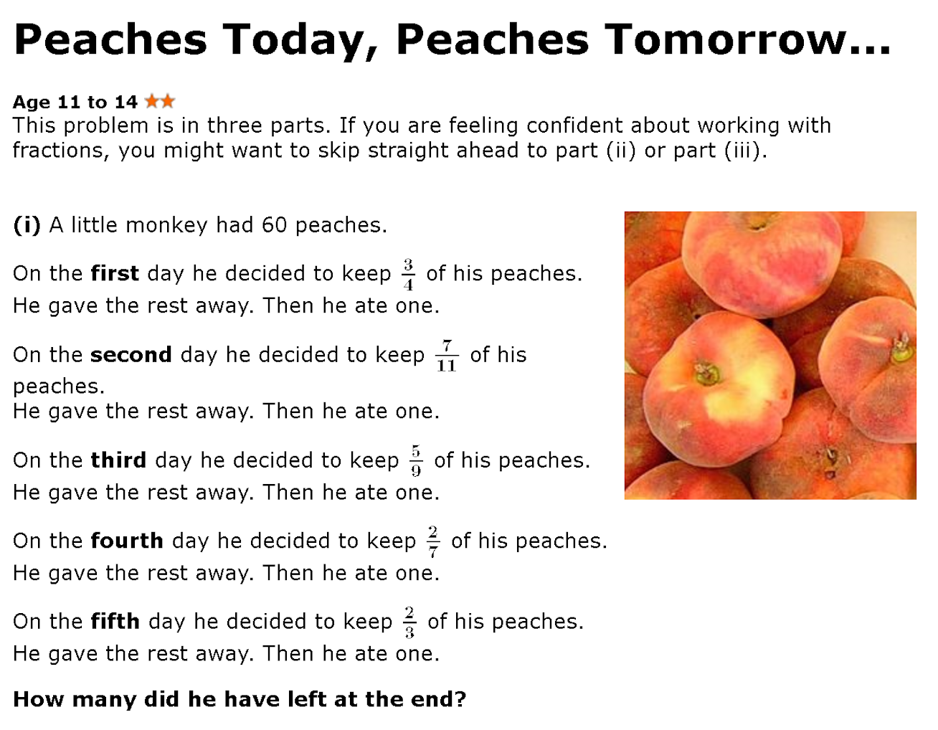

The first day, he had 60 peaches, and he decided to keep ¾ of his peaches. That means he gave away ¼ of his peaches, because ¾ + ¼ = 1, and the 1 represents 100% of his peaches. Anyway, ¼ of the 60 peaches is 15, and then he ate one peach, so 15 + 1 = 16 peaches is now gone from his collection. To figure out how many he had left, we can just subtract the number of peaches he had from the beginning minus the peaches he gave away and the one he ate everyday. That equals 60 - 16, which is 44, and that’s the first day. We can keep on going for the rest of the days, but the starting amount has to be the amount left the day before. So for the second day, there are 44 peaches, he gave away 7/11 of his peaches (16 peaches from the 44) and ate 1, which is 44 - 17, which is 27. Repeat this process until the fifth day, and at the end of the fifth day, he only has 1 peach left.

Day | Amount starting | Ate | Gave away | Amount left
1 | 60 | 1 | 15 | 44
2 | 44 | 1 | 16 | 27
3 | 27 | 1 | 12 | 14
4 | 14 | 1 | 10 | 3
5 | 3 | 1 | 1 | 1

The monkey had 1 peach left and why do monkeys eat peaches xd?

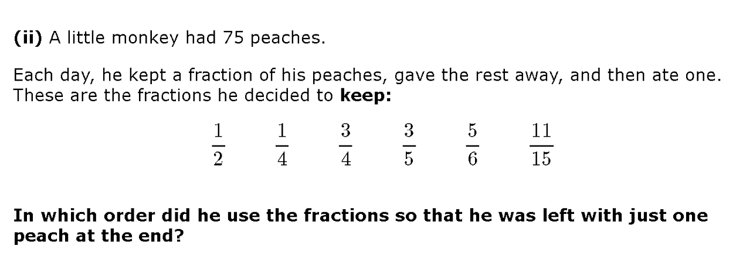

First, before we even thought about doing trial & error, we made a list of restrictions. First of all, the fraction on Day 1 has to be ⅗ or 11/15, because the starting amount, 75, is only divisible by 5 and 15. Also, on the last day, the fraction he wants to keep needs to be one of the unit fractions, or in other words, ½ or ¼, or a fraction with the numerator as 2. This is because if you have any other fraction, like ⅗, and you have a number like 5, the number would be 3, and if you subtract 1, it would still be 2 peaches. But if you had ⅖, and the number was 5, the result would be 2, and minus 1 would be 1. Same applies for the unit fractions, but the denominator has to be half the amount starting, so for example, you would have to have 8 for ¼ to work, or 4 for the ½.

Day | Amount starting | Ate | Kept | Gave away | Amount left
1 | 75 | 1 | 11/15 | 20 | 54
2 | 54 | 1 | 5/6 | 9 | 44
3 | 44 | 1 | 3/4 | 11 | 32
4 | 32 | 1 | 1/2 | 16 | 15
5 | 15 | 1 | 3/5 | 6 | 8
6 | 8 | 1 | 1/4 | 6 | 1

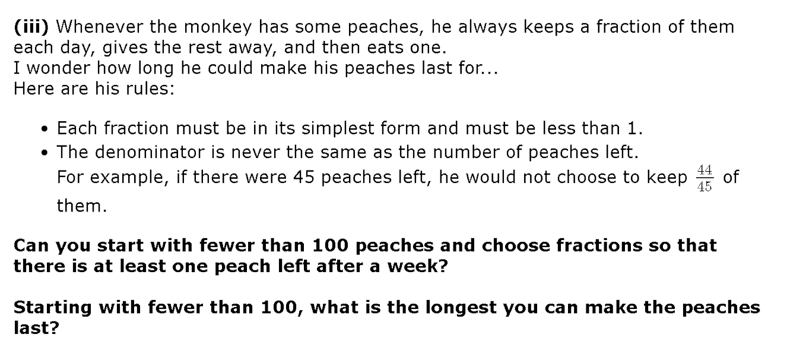

Section 1.
In this section, we had to see how long the peaches could last. First, we started with 99, which was the biggest possible number to start with. Then, we found the greatest common factor of all the numbers, and then made that the denominator. For example, if the monkey had 45 peaches, the greatest common factor is 15, so the denominator would be 15. For the numerator, we could just put 1 less than the current denominator, so it would be 14/15. But there are times where the resulting amount left would be a prime number. In that case, we could just lower the numerator by 1. Then try again. Keep doing that until the amount left is not a prime number. We did that process until we got to the end of the 7th day, which is a week.

Day | Starting amount | Ate | Kept | Gave away | Amount left.
1 | 99 | 1 | 32/33 | 3 | 95
2 | 95 | 1 | 4/5 | 19 | 75
3 | 75 | 1 | 11/15 | 20 | 54
4 | 54 | 1 | 5/6 | 9 | 44
5 | 44 | 1 | 10/11 | 4 | 39
6 | 39 | 1 | 12/13 | 3 | 35
7 (one week) | 35 | 1 | 4/5 | 7 | 27
8 (in case it had to be 8 days xd) | 27 | 1 | 8/9 | 3 | 23

Section 2.
In this section, we had to see how long the peaches could last. First, we started with 99, which was the biggest possible number to start with. Our method was to find the biggest factor of the number of peaches we had to be the denominator of the amount of peaches we keep and use the biggest possible numerator. For instance, 32/33 of 99. Then, we subtract 1. If the fraction makes a prime number after subtracting 1, then we make the numerator 1 less and see if it works then. If is still doesn’t work, we keep going with the process. We kept doing that until we could no longer do it.

Day | Starting amount | Ate | Kept | Gave away | Amount left
1 | 99 | 1 | 32/33 (96) | 3 | 95
2 | 95 | 1 | 17/19 (85) | 10 | 84
3 | 84 | 1 | 41/42 (82) | 2 | 81
4 | 81 | 1 | 26/27 (78) | 3 | 77
5 | 77 | 1 | 10/11 (70) | 7 | 69
6 | 69 | 1 | 22/23 (66) | 3 | 65
7 | 65 | 1 | 11/13 (55) | 10 | 54
8 | 54 | 1 | 26/27 (52) | 2 | 51
9 | 51 | 1 | 15/17 (45) | 6 | 44
10 | 44 | 1 | 10/11 (40) | 4 | 39
11 | 39 | 1 | 12/13 (36) | 3 | 35
12 | 35 | 1 | 5/7 (25) | 10 | 24
13 | 24 | 1 | 11/12 (22) | 2 | 21
14 | 21 | 1 | 5/7 (15) | 6 | 14
15 | 14 | 1 | 5/7 (10) | 4 | 9
16 | 9 | 1 | 2/3 (6) | 3 | 5

